IE 5390 – Assignment - 01

Name: Simran Abhay Sinha

**Lab 01**

2. Clean the data so that all the attributes have their own columns, i.e., 12 columns.  
Clean the header row so that only the attribute names are displayed, without any  
quotation marks or special characters.

Result:

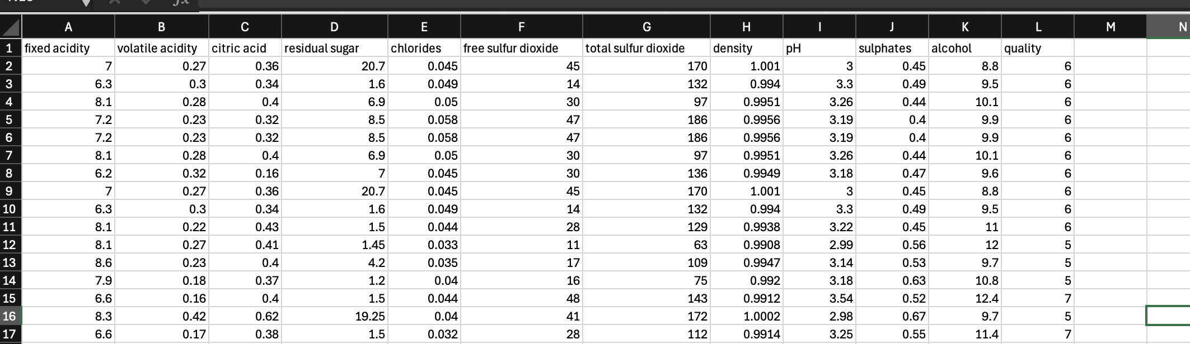  
  
3. Create a column called “Wine_Type” and place it right at the beginning of both red  
and white wine files. For the red wine data, add the label “Red” under “Wine_Type”.  
Similarly, for the white wine data, add the label “White” under “Wine_Type”. Both  
datasets should now consist of 13 columns.

Result:

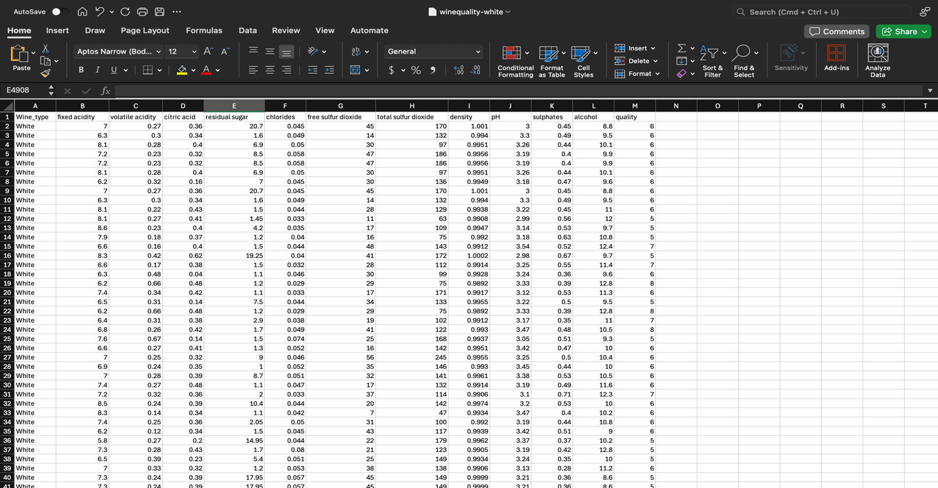

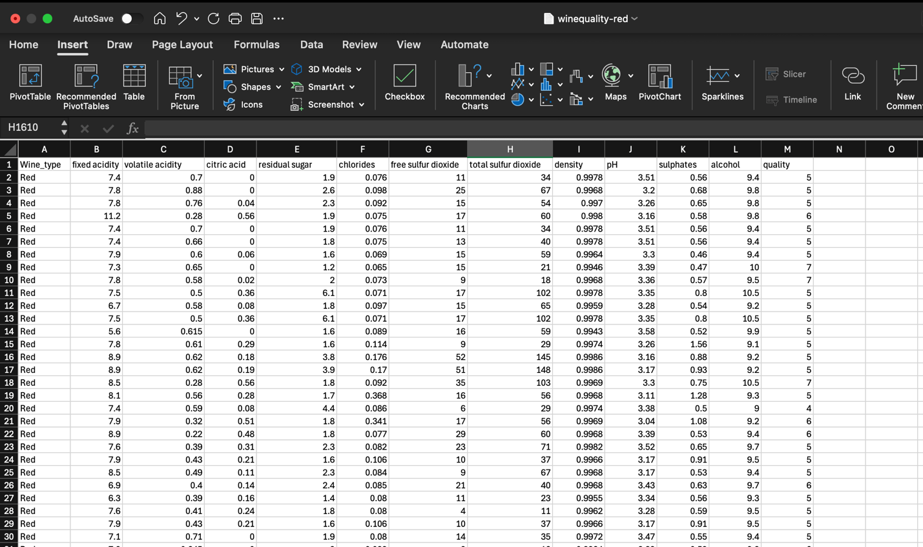

4. Combine both the red and white wine datasets. Combined dataset should have all red  
wine records first and then the white wine records. There will be a total of 6,497  
records excluding the header row. Name the dataset “wine_combined.xlsx”  
Result:

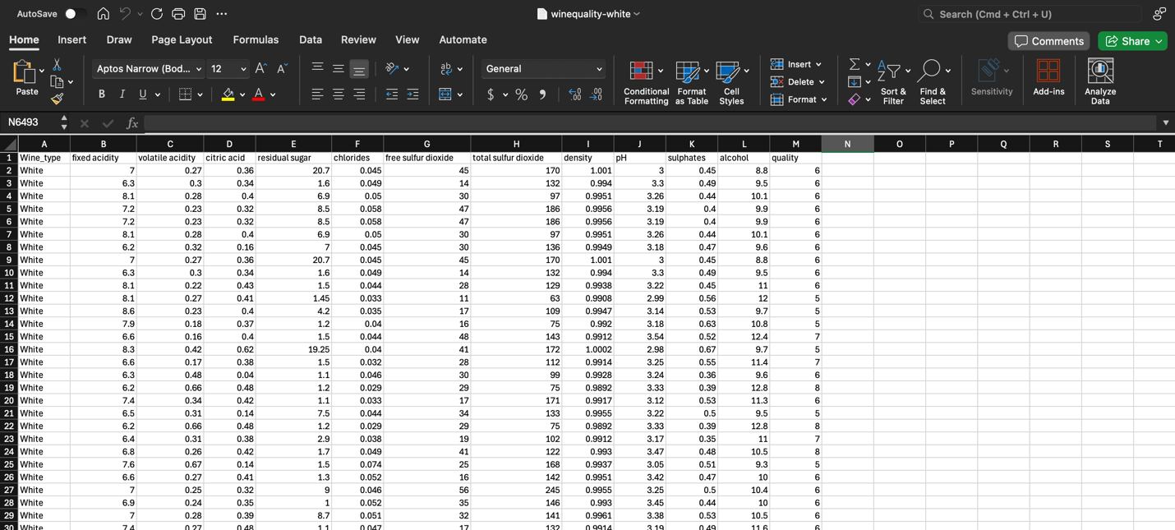

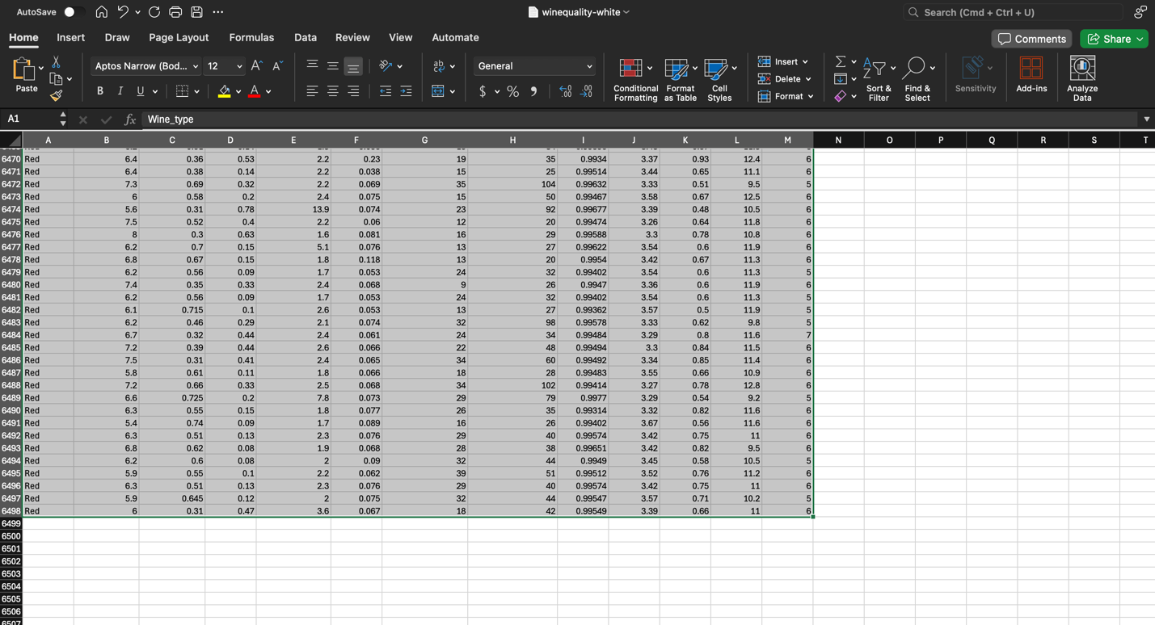

5. Check the data for missing values using both the methods discussed in class  
Result:

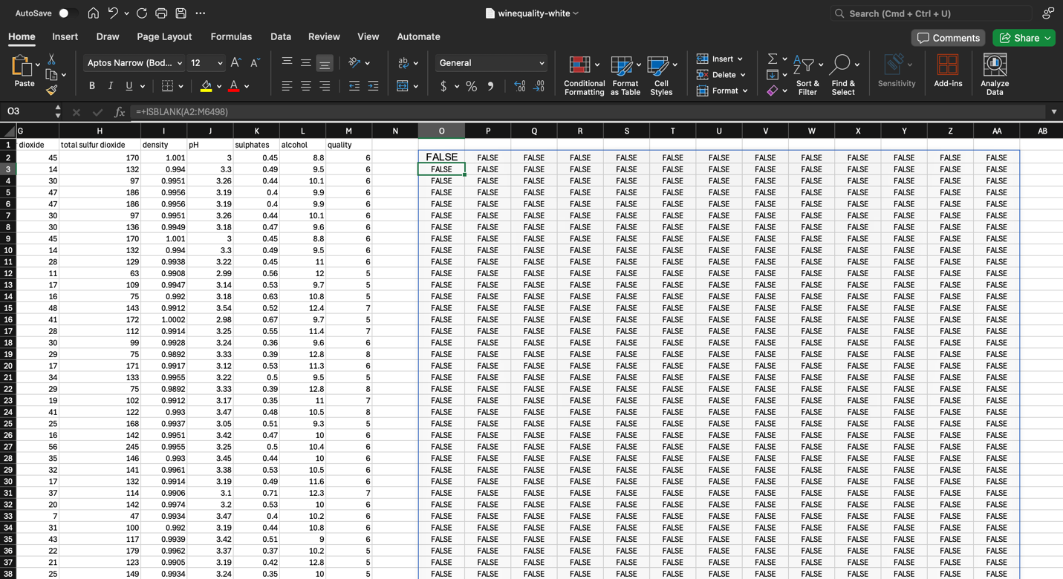

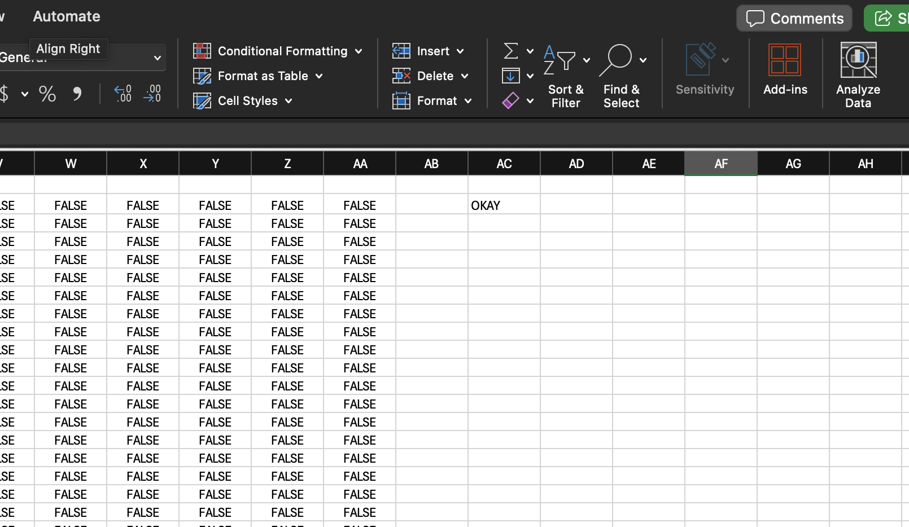

6. Remove any leading and trailing spaces that the data and headers may have  
Result:

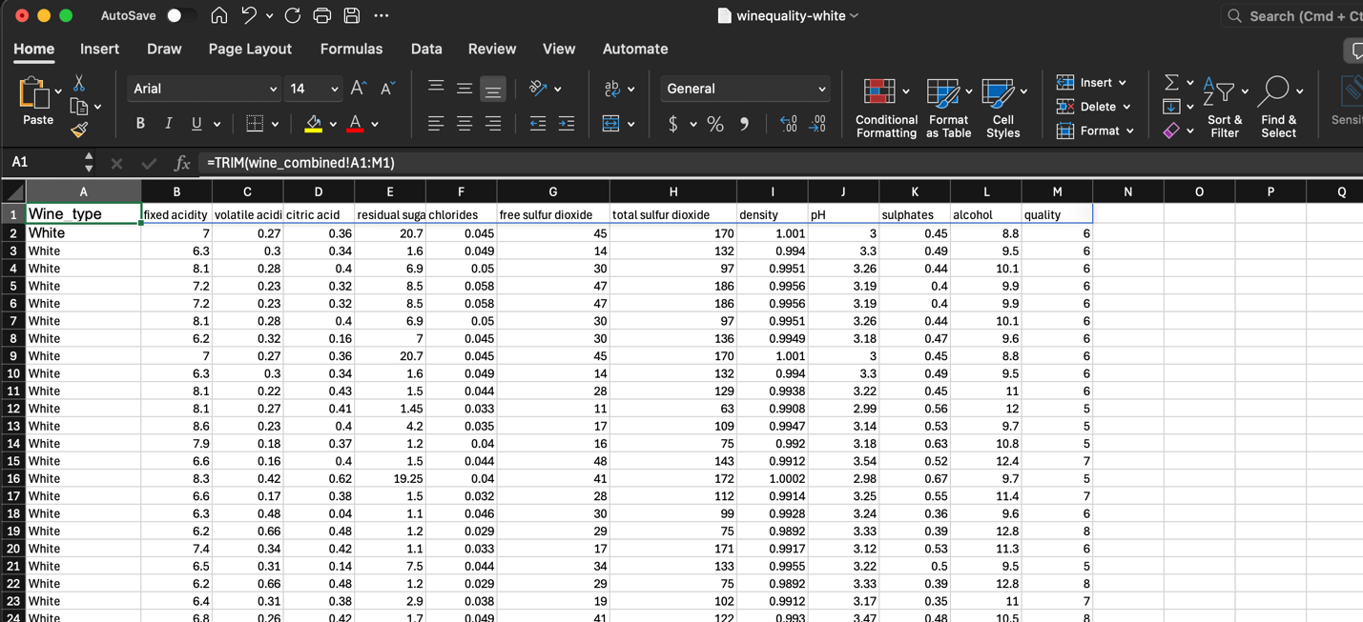

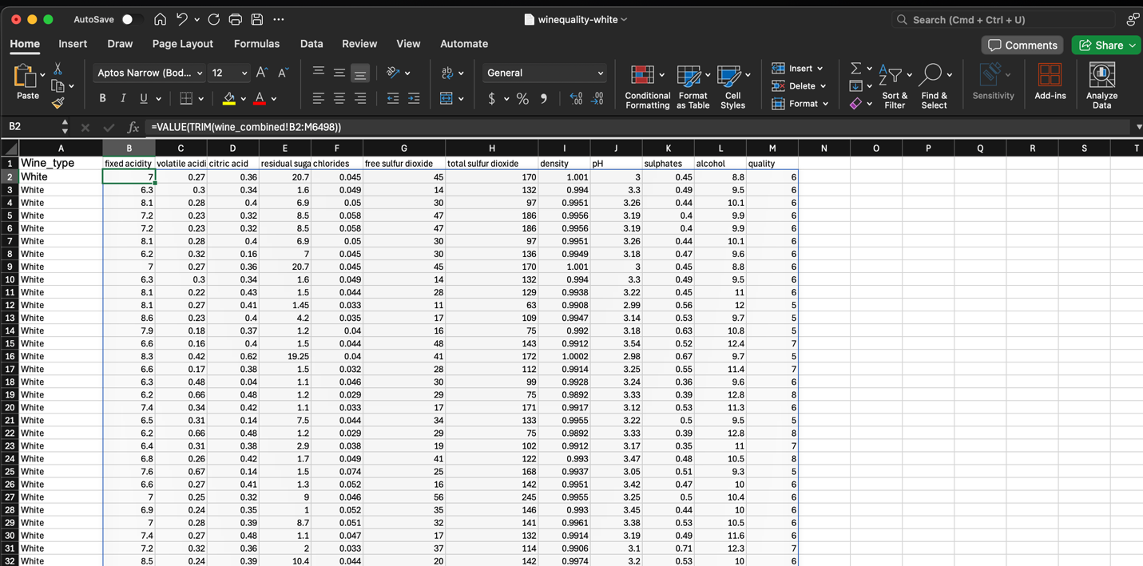

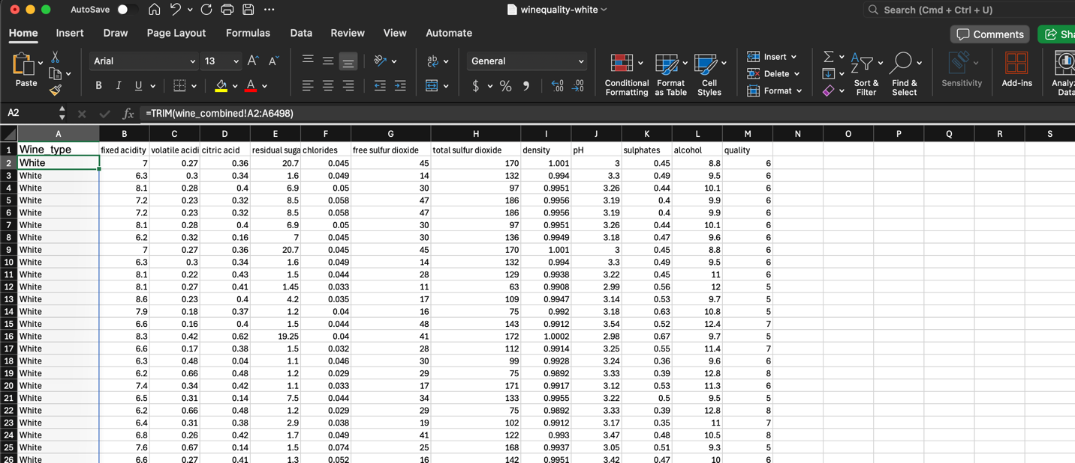

7. Create an attribute with equally sized bins for the ‘free sulfur dioxide’ attribute. You  
may choose the number of bins.  
Result:

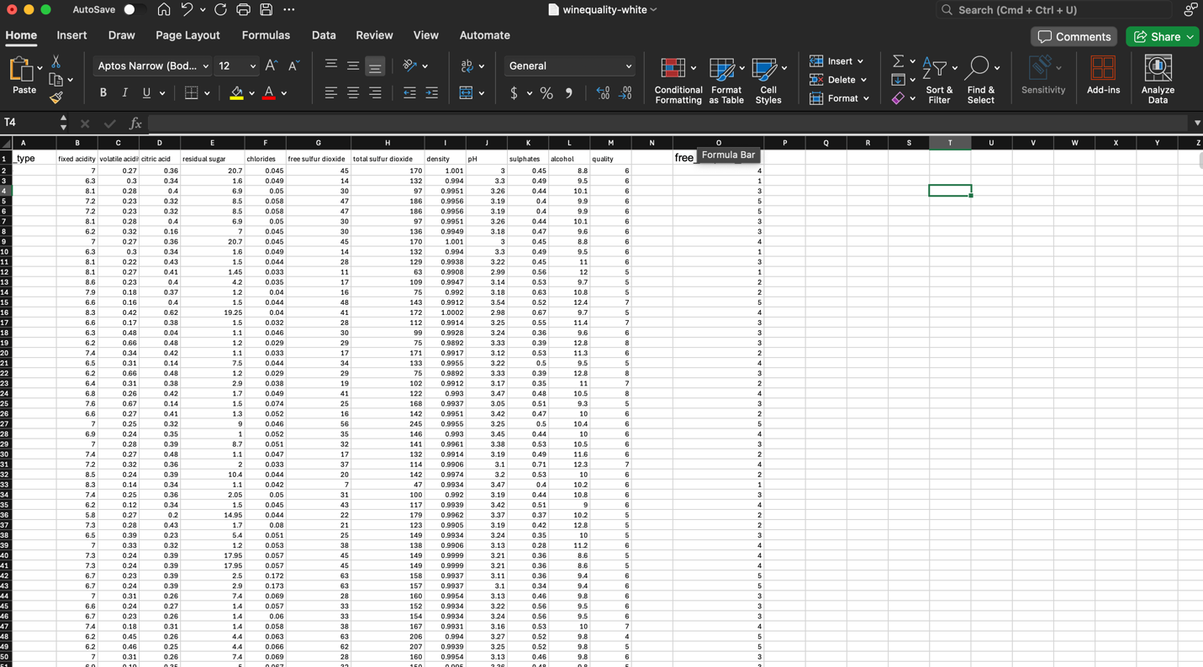

8. Create a categorical attribute based on the column ‘quality’. This new categorical  
attribute should consist of 3 levels: ‘bad, ‘good’ and ‘best’ defined as follows:  
quality of less than 4 – ‘bad’  
quality between 4 and 7 – ‘good’  
quality greater than 7 – ‘best’  
Result:

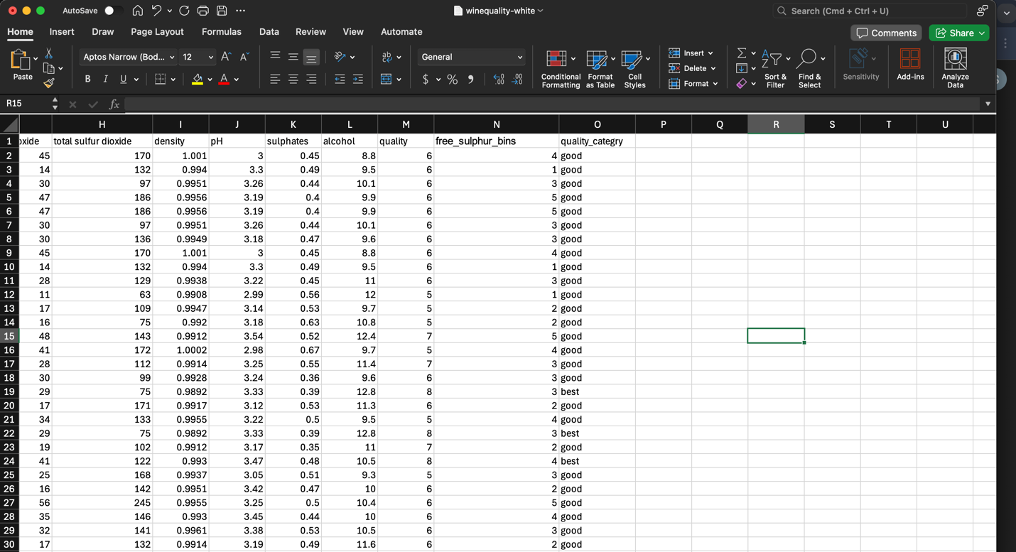

9. Use the internet or Gen AI to do some research on Excel’s Conditional Formatting.  
Now, use conditional formatting to color the row in green if the quality of wine is  
greater than 7. If the quality of wine is lesser than 7, color the row yellow.  
NOTE: You must use conditional formatting and show screenshots for how you have  
achieved the result. MacOS users may face some issues while attempting this. Create  
the conditional formatting rule regardless – you will be graded on the creation of the rule.  
Result:

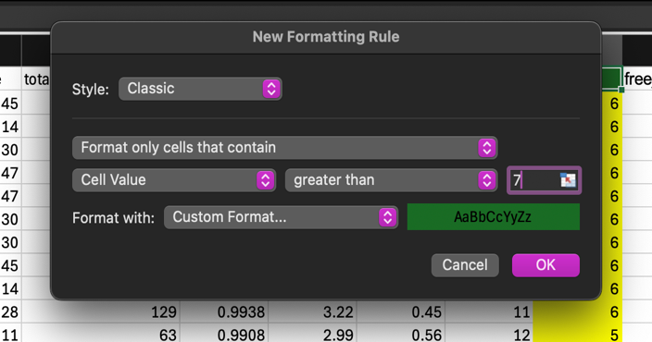

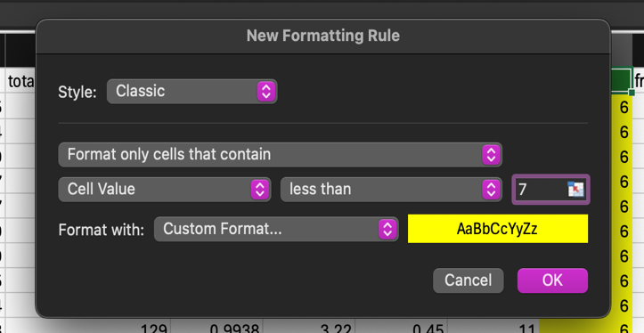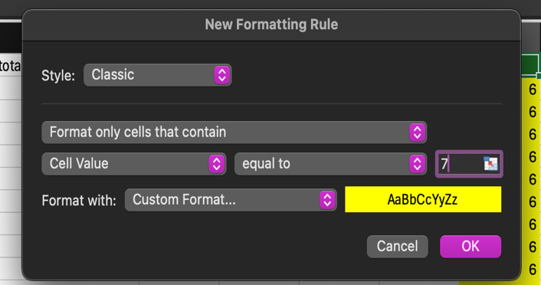

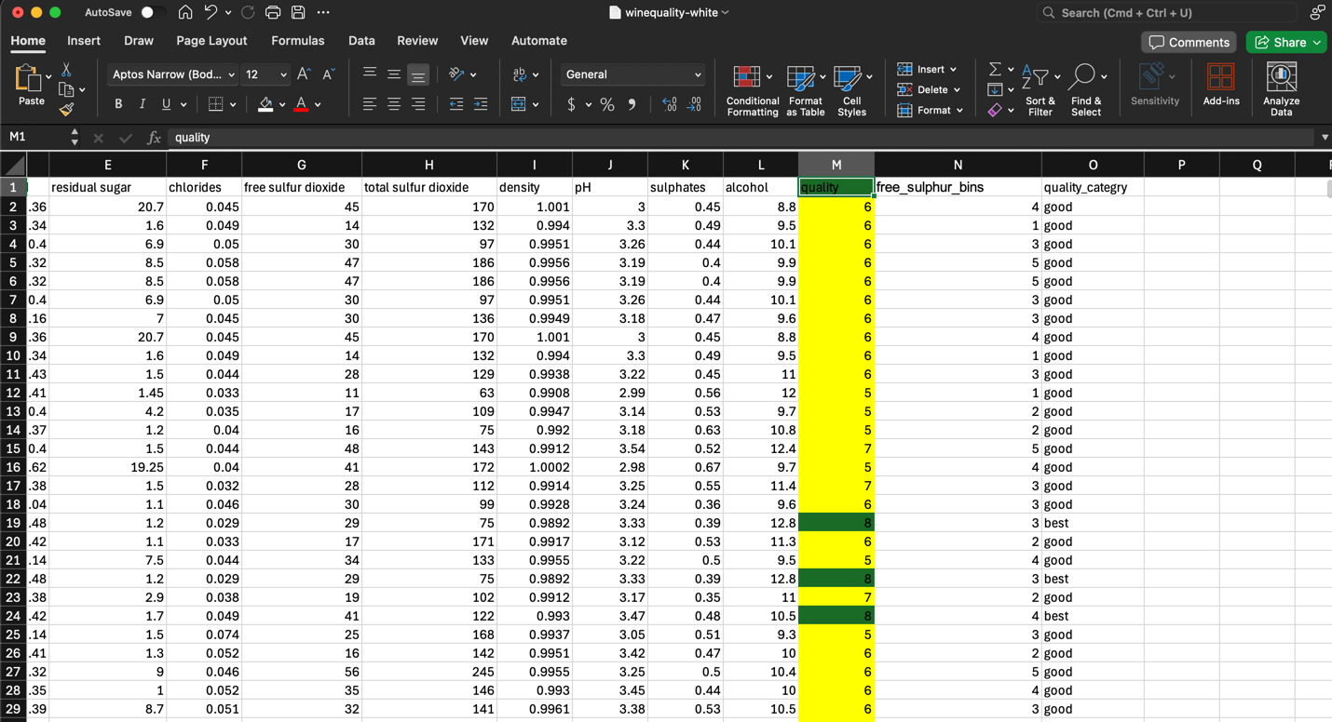

10. Gen AI Prompt Engineering: use your favorite AI Chat Bot to perform same work we  
did in class on boston_housing dataset, i.e clean data, manipulate data, analyze data,  
and viz data. While doing this task, you may need to subscribe to one of the bots, e.g.  
Chat GPT.  
Solution:  
I am using Perplexity.ai

Prompt:  
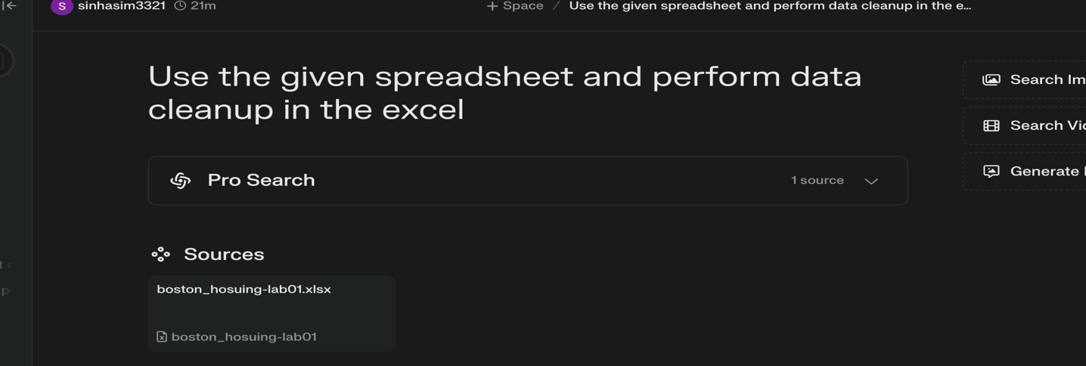

Solution by AI:  
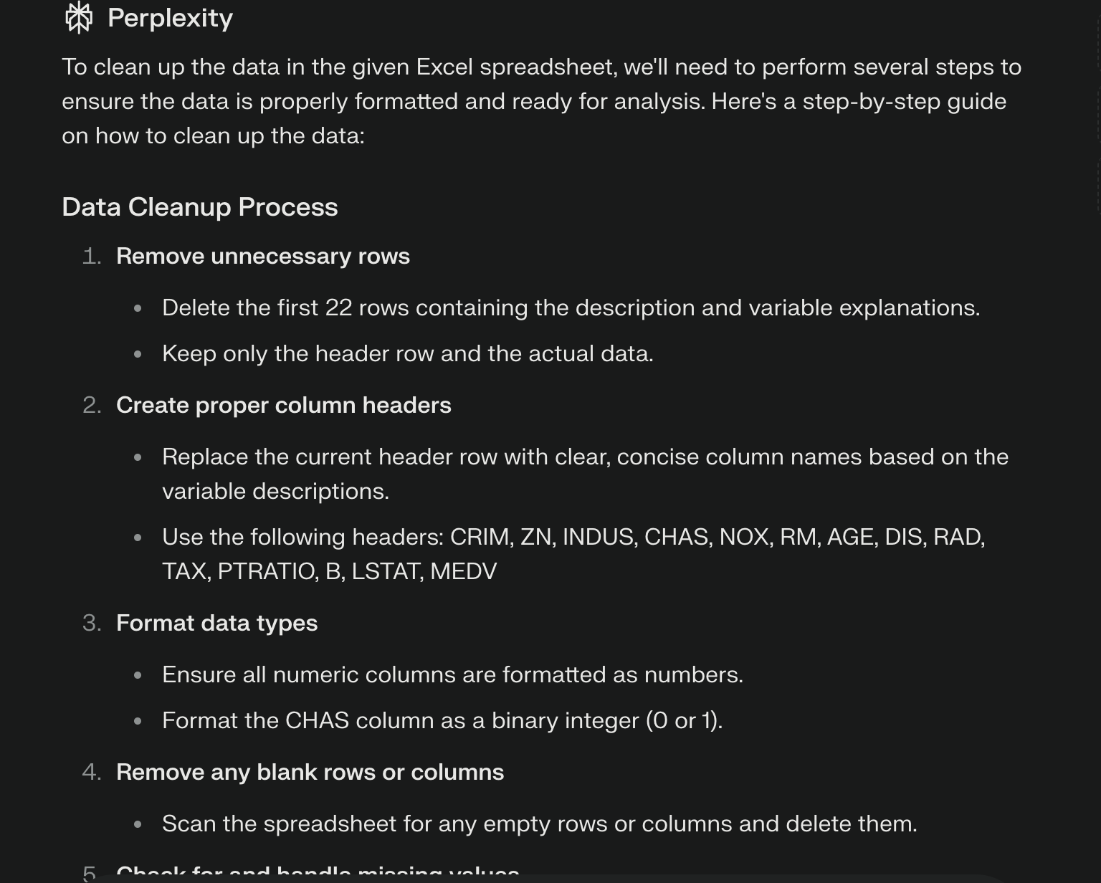

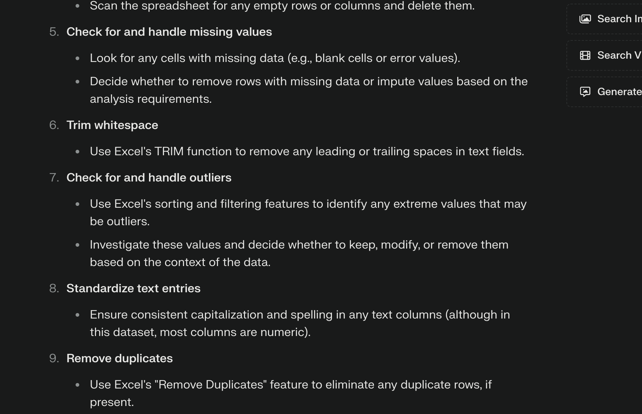

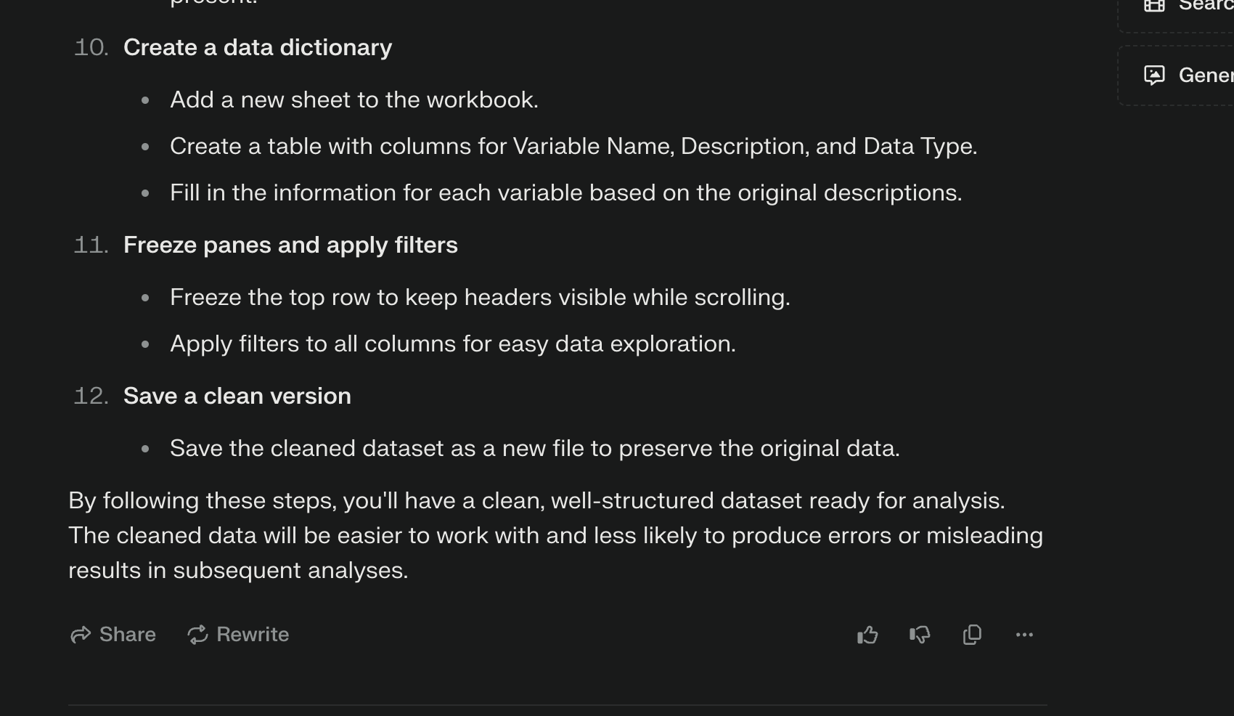

Excel:

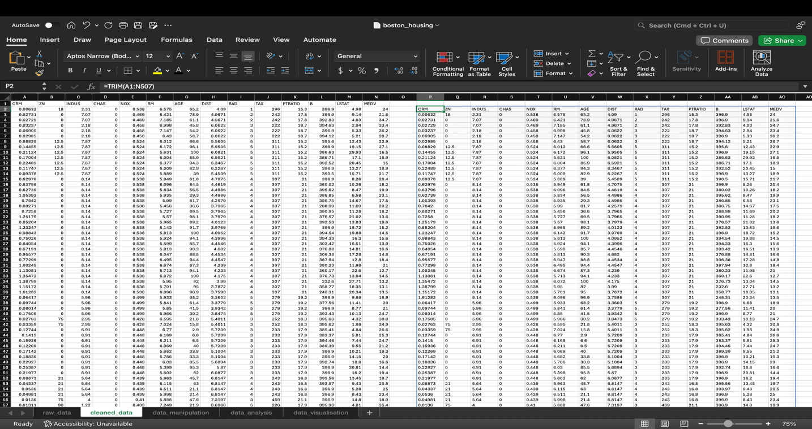

Prompt:  
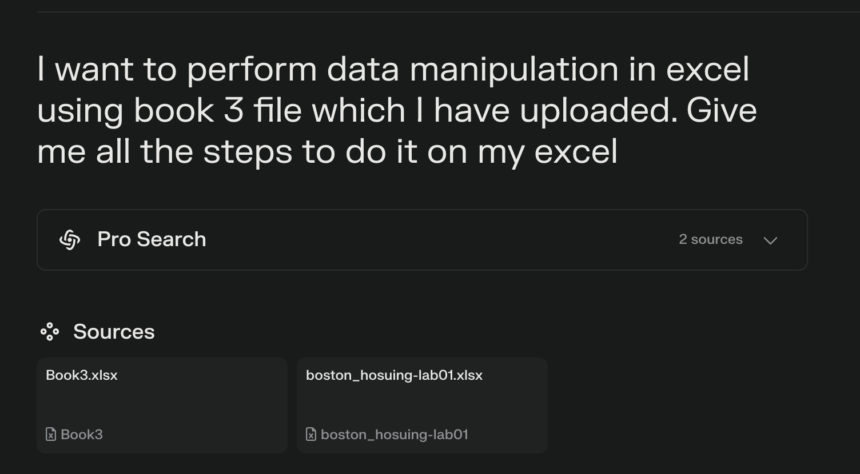

Solution by AI:  
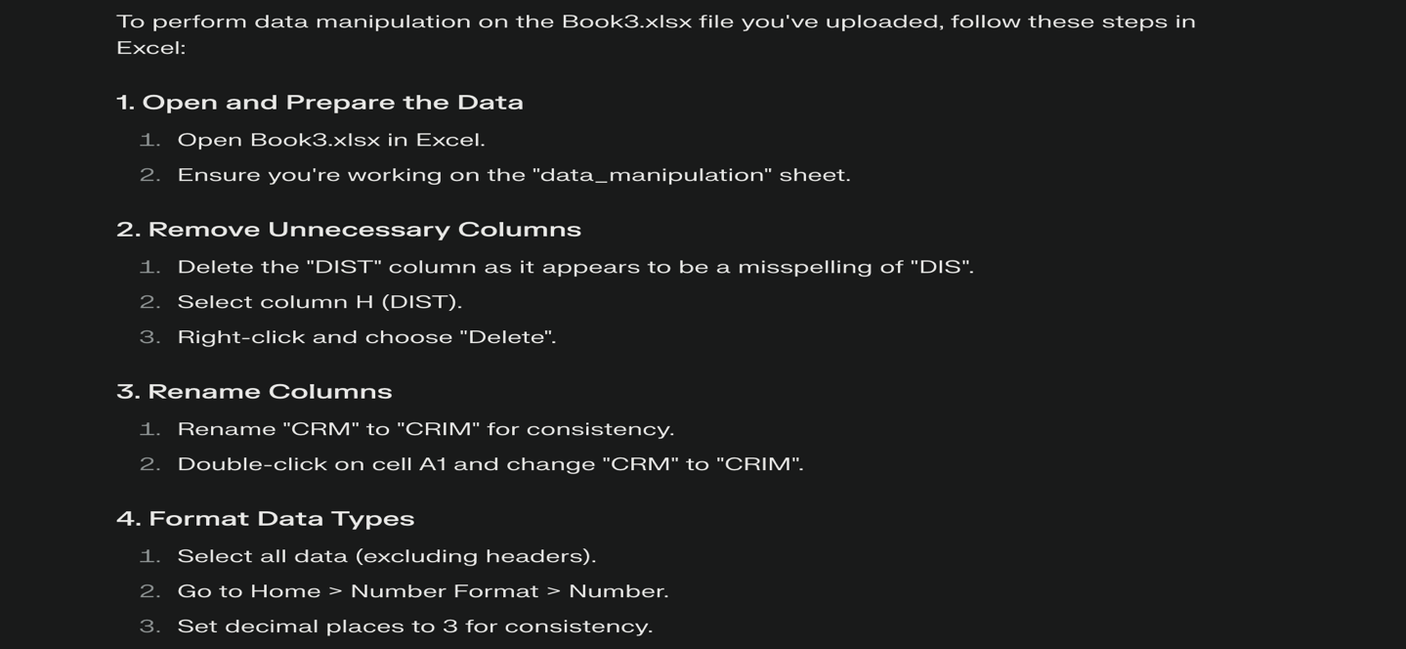

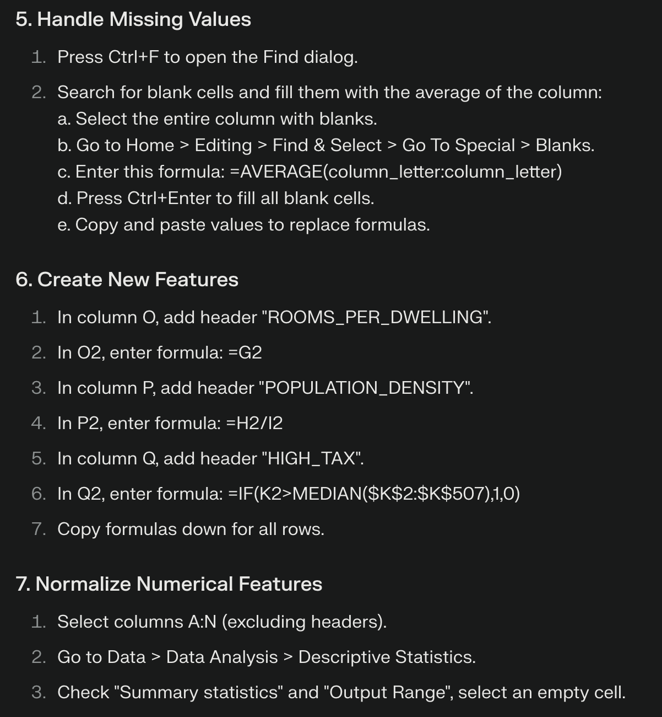

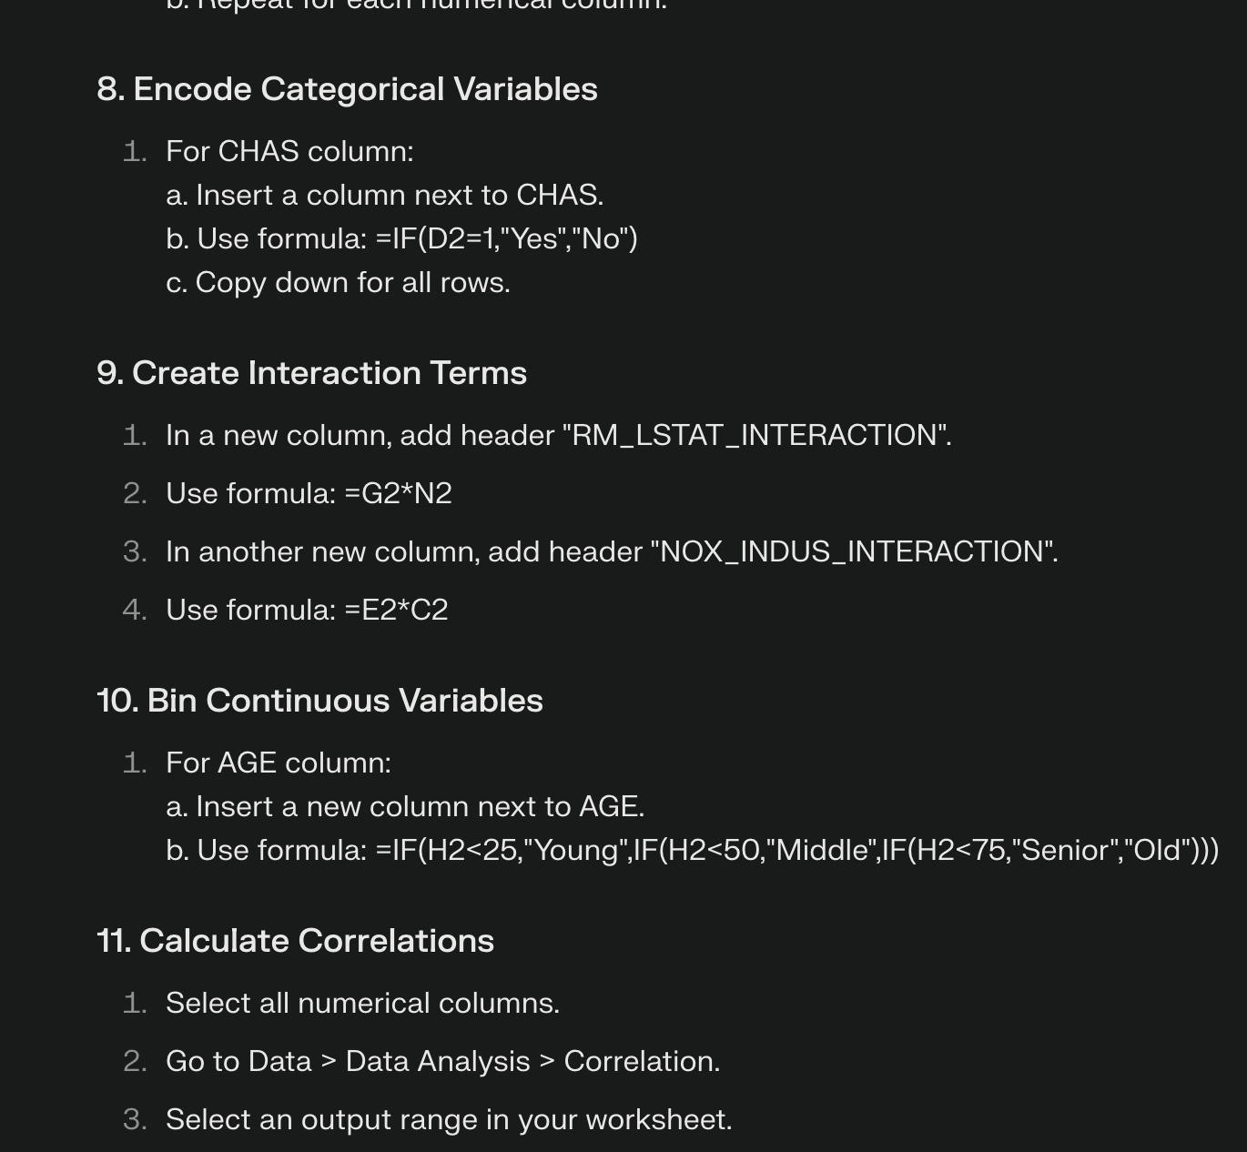

Excel:  


Prompt: 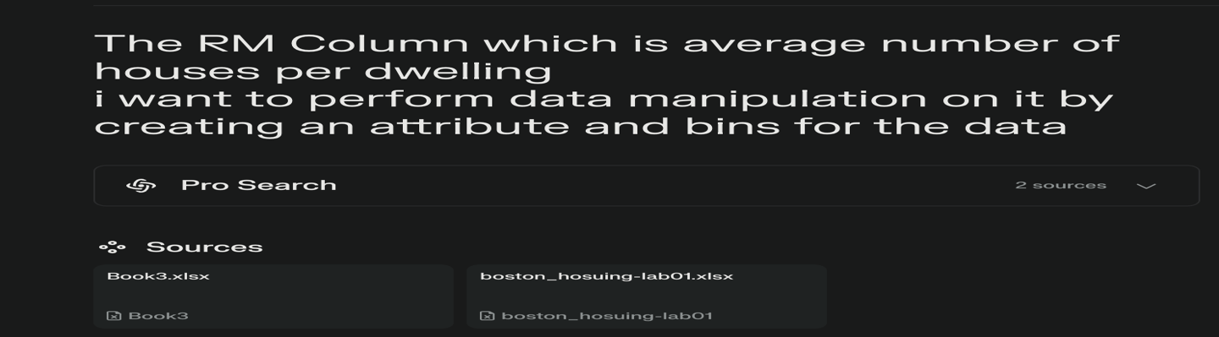

Solution by AI: 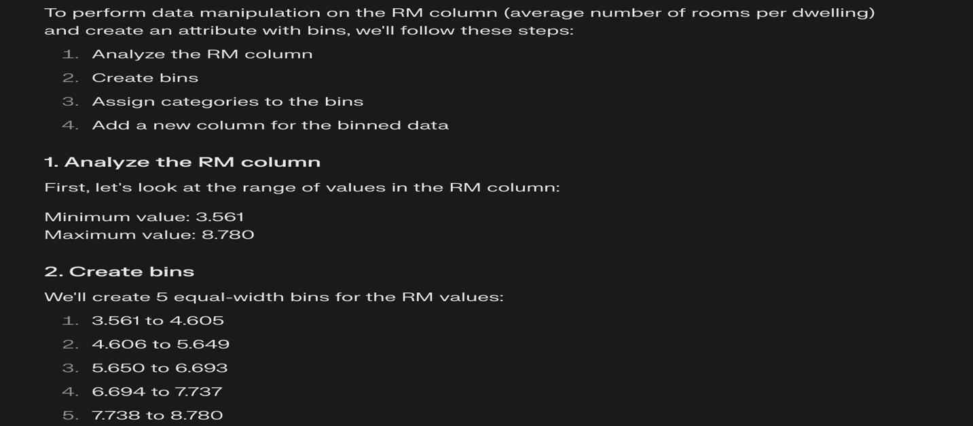  
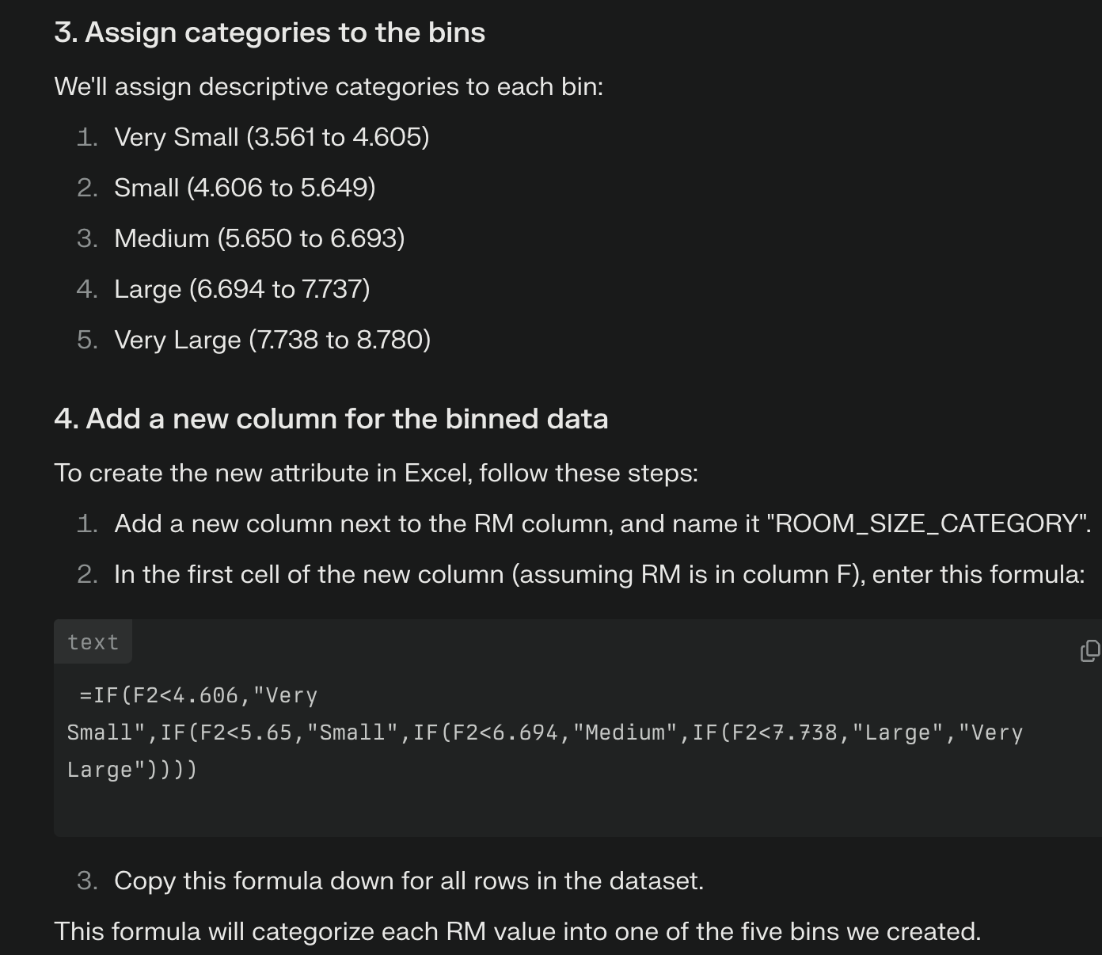  
Excel:

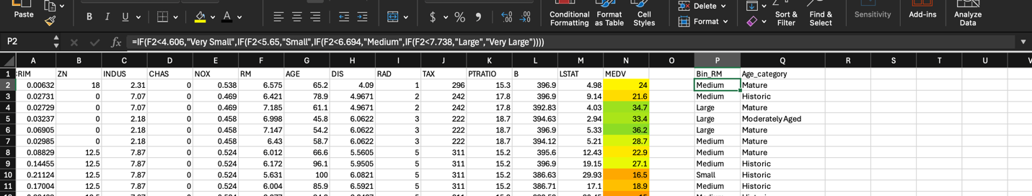

Prompt: 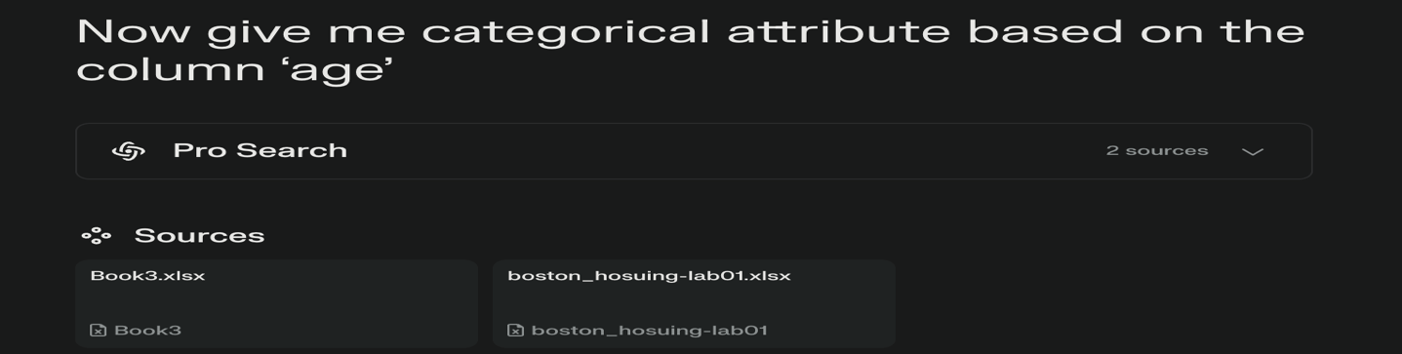  
Solution by AI: 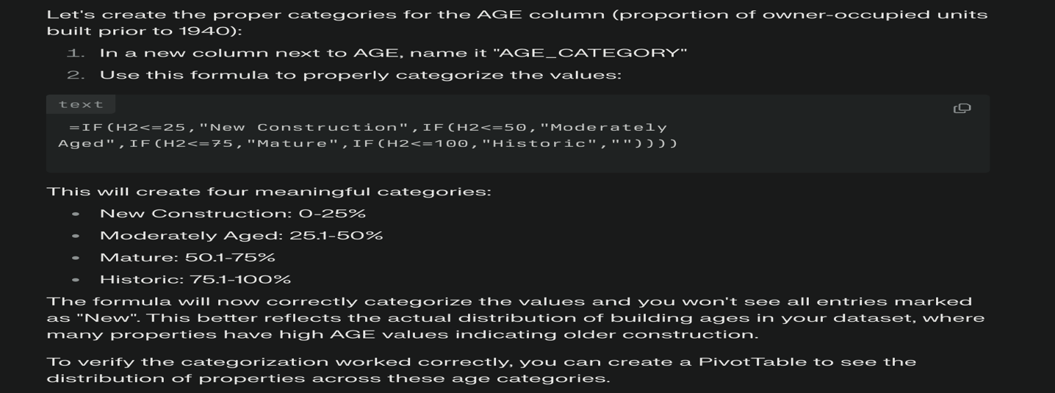  
Excel:

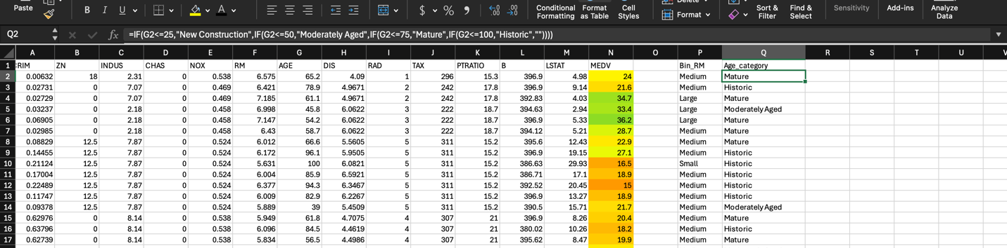

Prompt: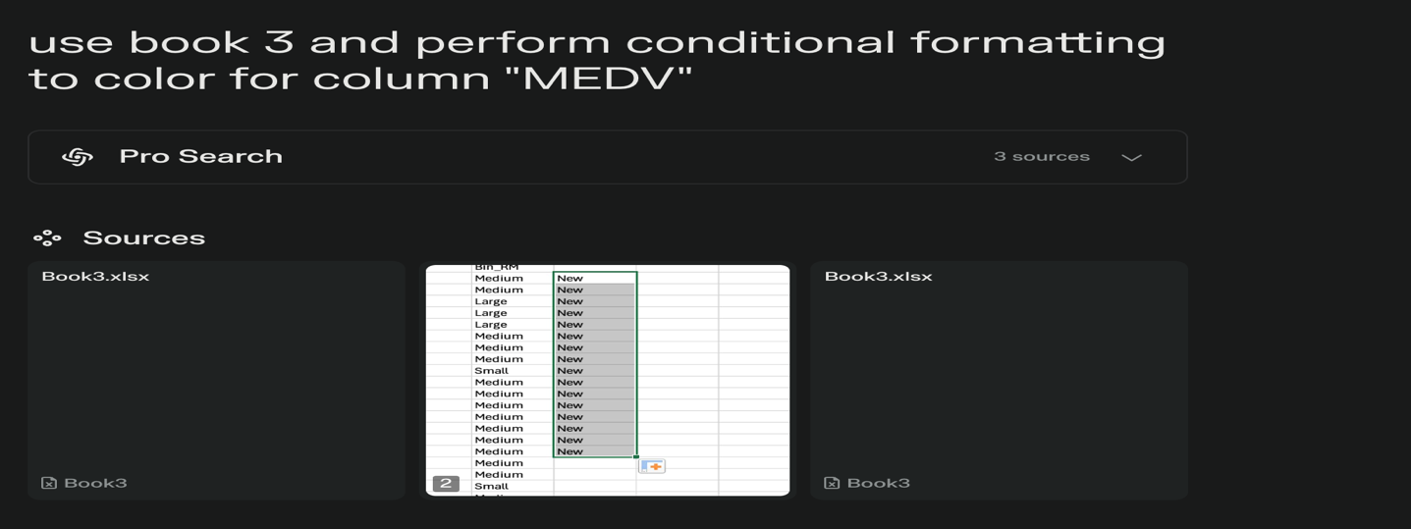  
Solution by AI:  
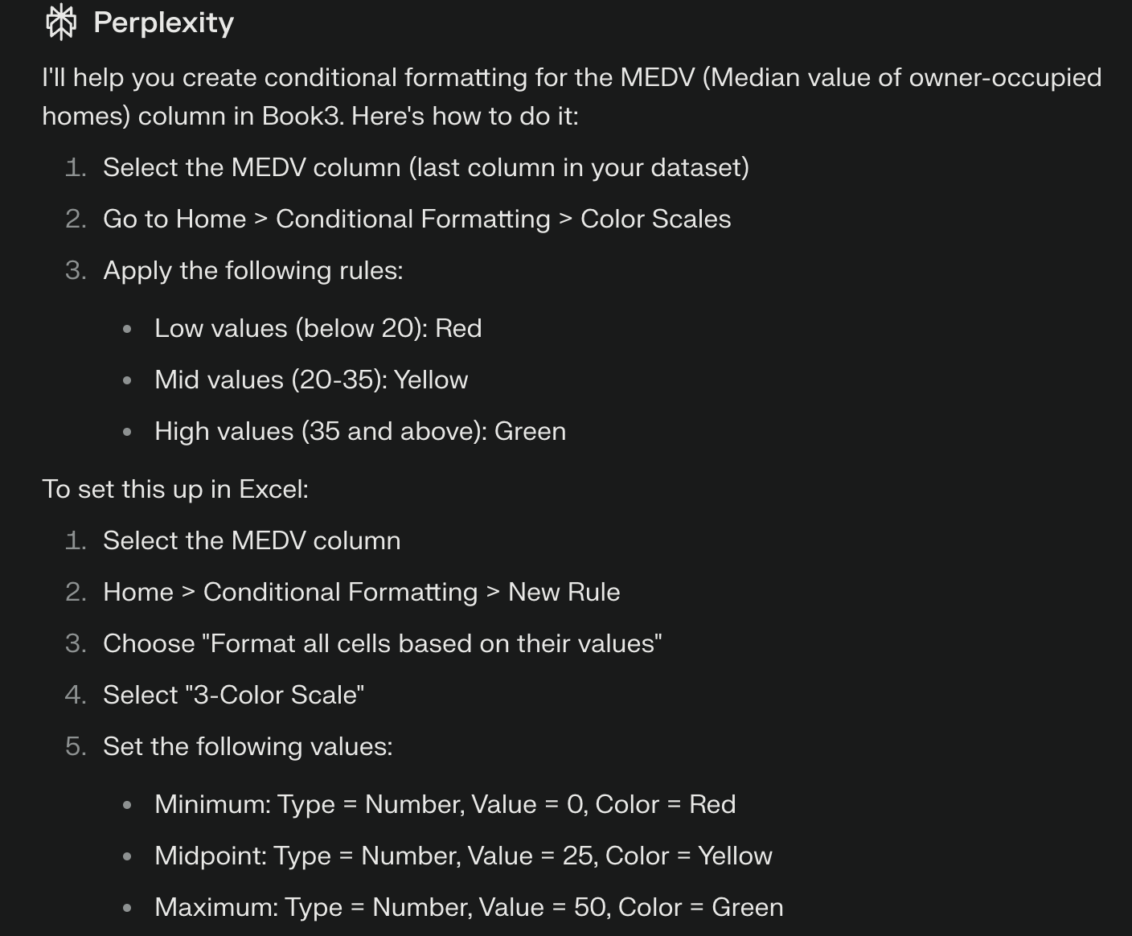  
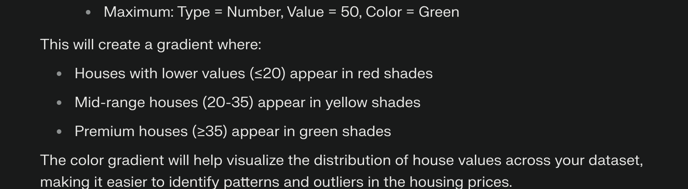  
Excel:

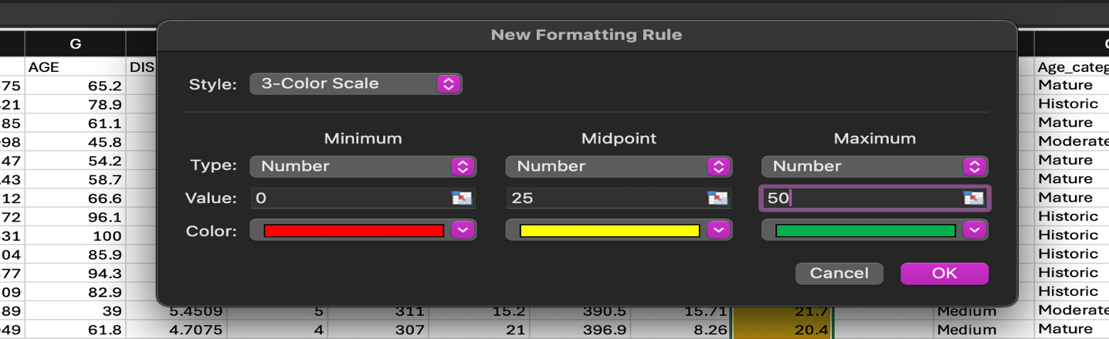

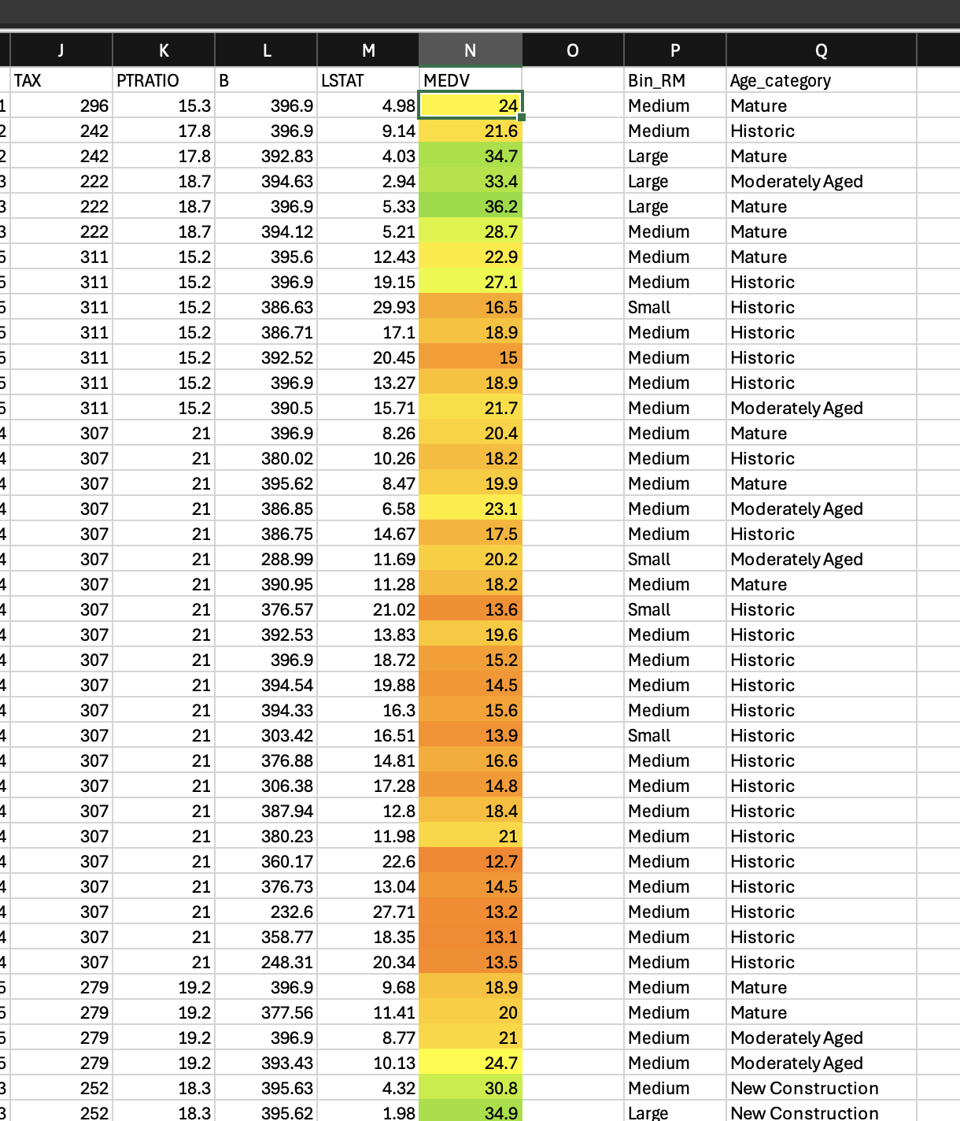  
Prompt:

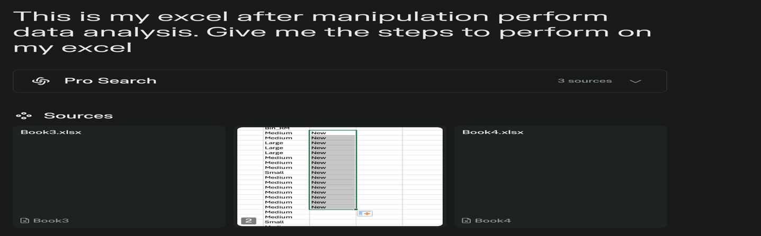  
Solution by AI:  
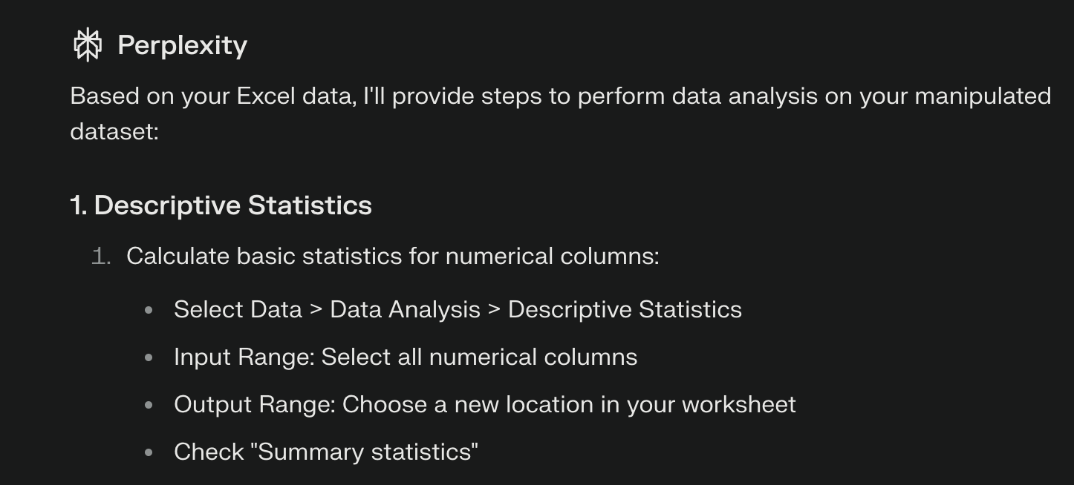  
Excel:  
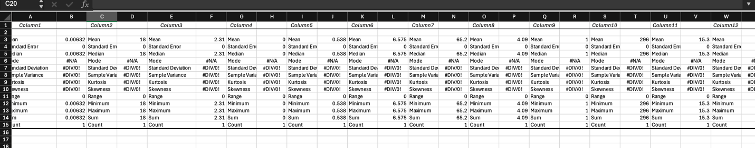

Prompt:  
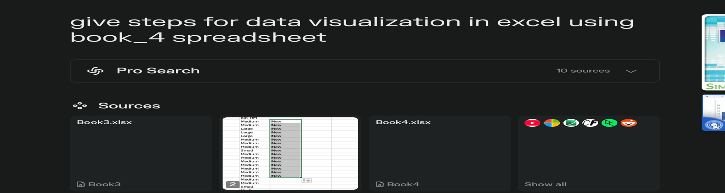

Solution by AI:

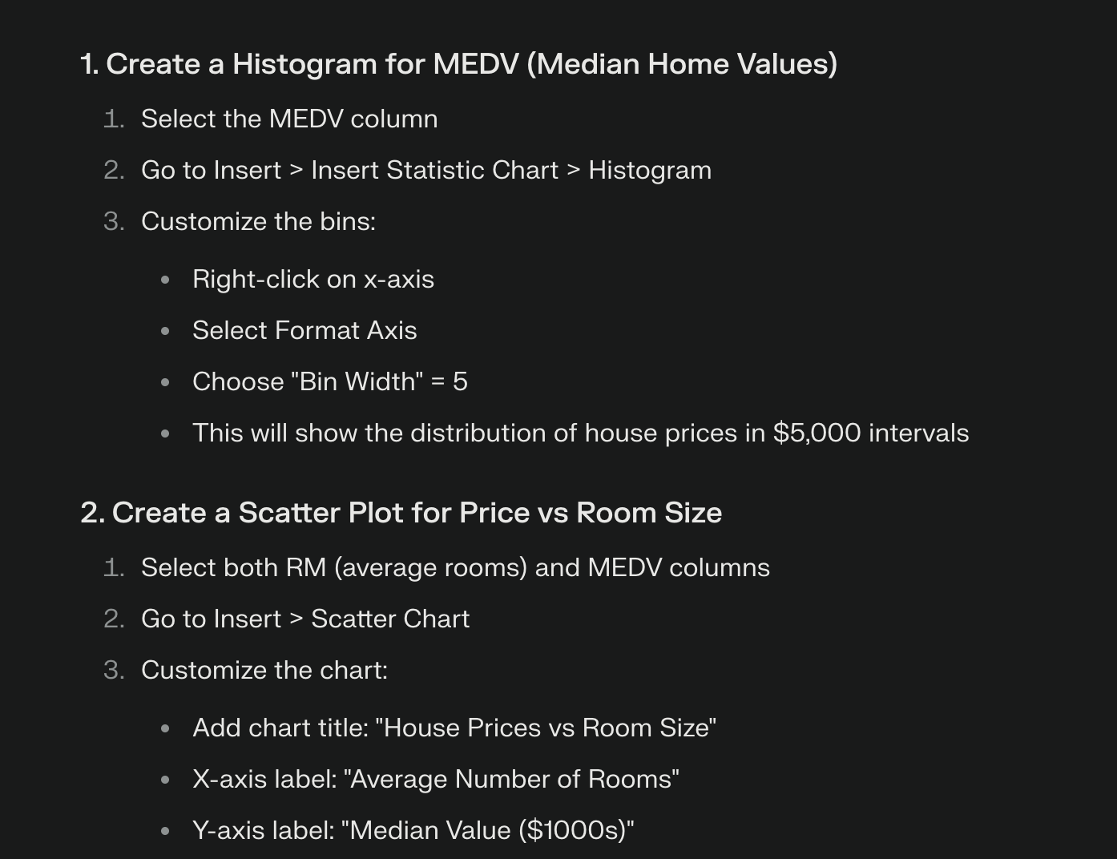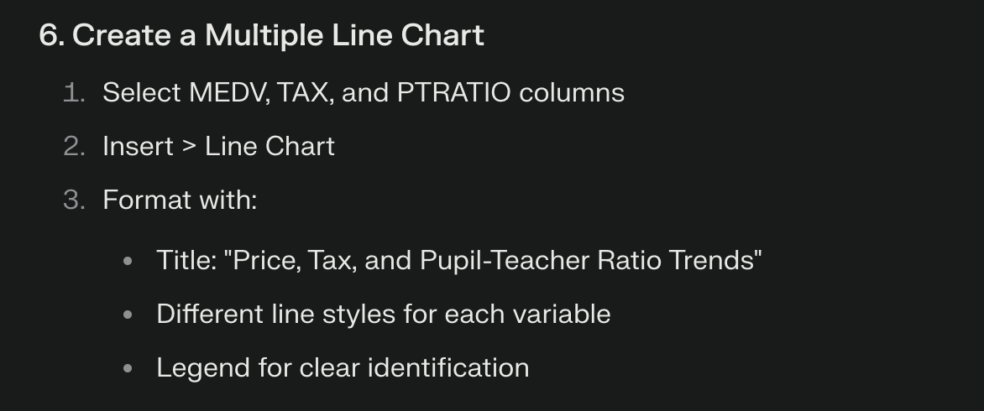

Excel:  
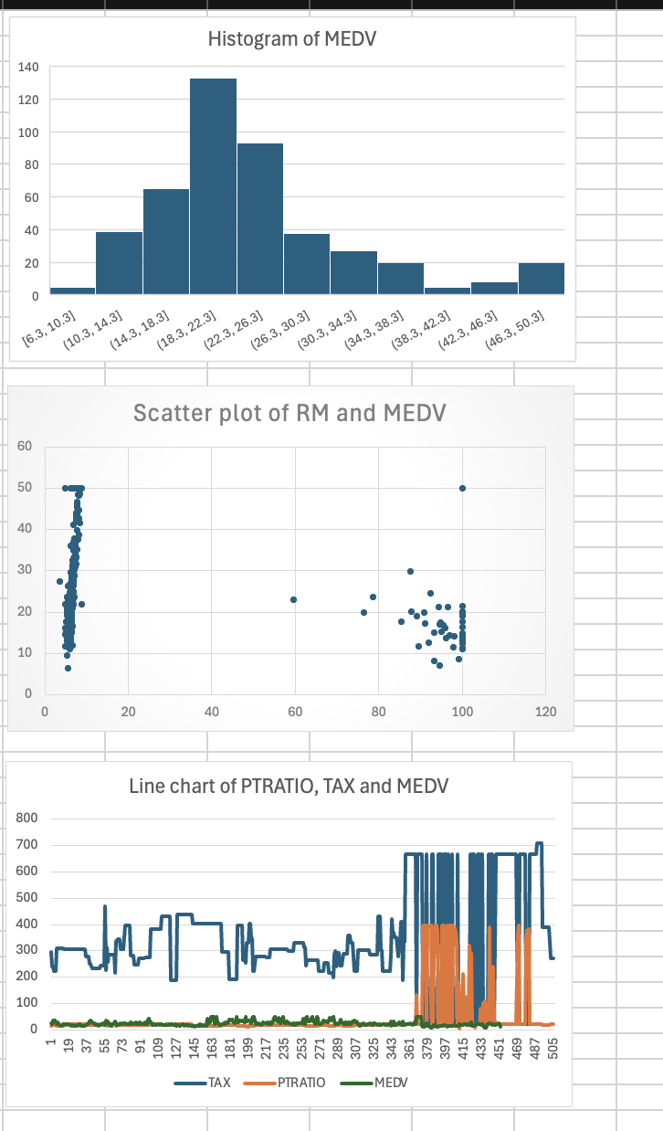

**Lab 02**

**PART I**

Use the “Internet Technology.xlsx” dataset. Create a worksheet and do the following:  
1. Create a stacked-column chart for the five time periods for both Arts Majors and Science  
Majors. Let Time on the Internet be your X-axis category label and put Major in the  
legend. Move the legend to the bottom of the chart. Include an appropriate chart title  
and label your axes appropriately.

2. Create a 3-D pie chart of the total data (combining majors). Include an appropriate  
title. Remove the legend and display data labels for the category name and  
percentage. Create the chart on the worksheet and move it below the first chart. Rotate  
the pie to display the largest slice at the front. Explode this one slice of the pie

**PART II**  
Use the “Antivirus Sales.xlsx” dataset. Create a worksheet and do the following:  
1. Create a Line Chart with each line representing the Free-trial, basic and advanced.

2. Create a Grouped Bar chart with a bars for Free-trial, basic and advanced.   
3. Create sparklines for each of the categories as seen in class

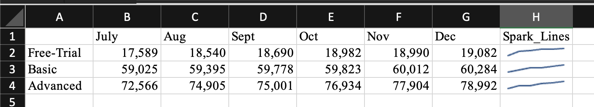

**PART III Gen AI**I am using Perplexity

1.Use the StateSales sheet in the “more charts.xlsx file to create the pareto chart  
we did in class. Ask the bot to explain the 80/20 rule in the resulting chart.  
What does it mean.

Prompt:  
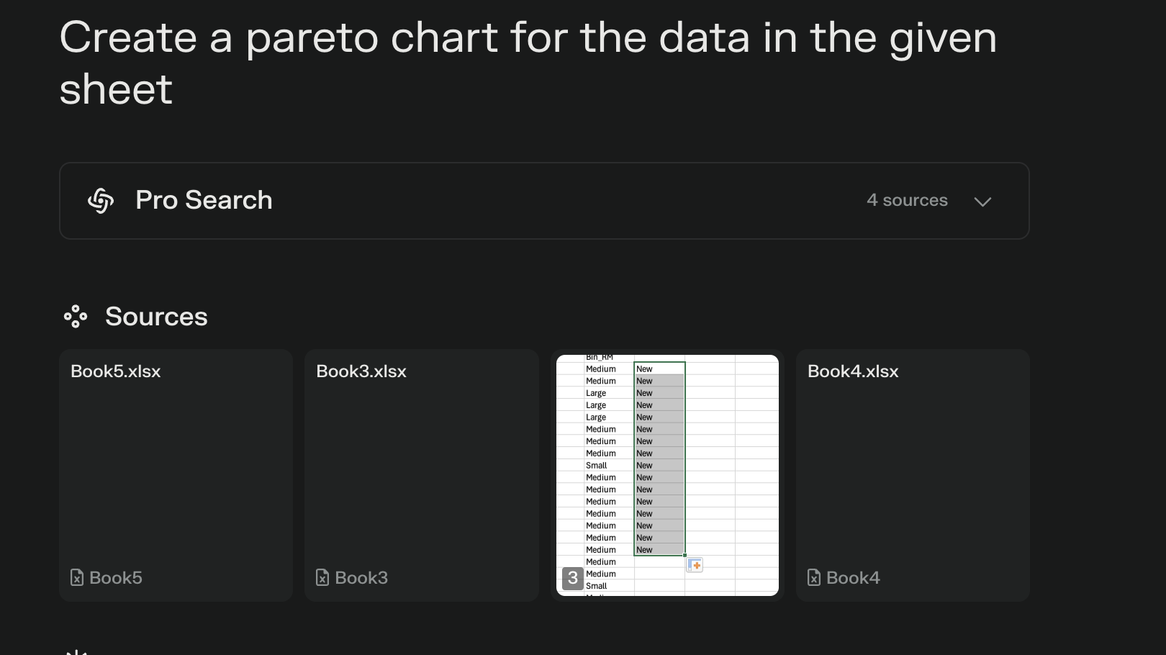  
Solution by AI: 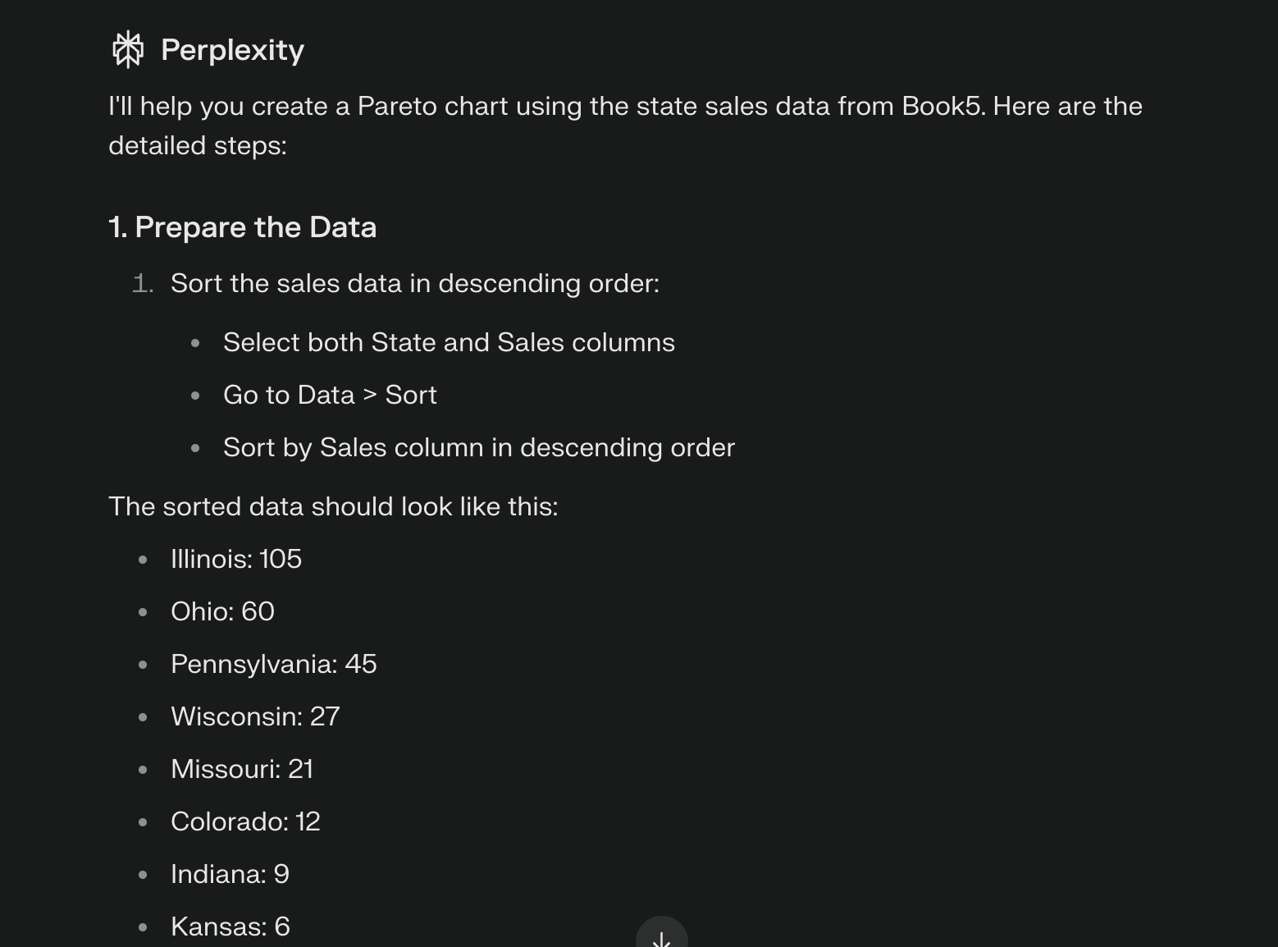

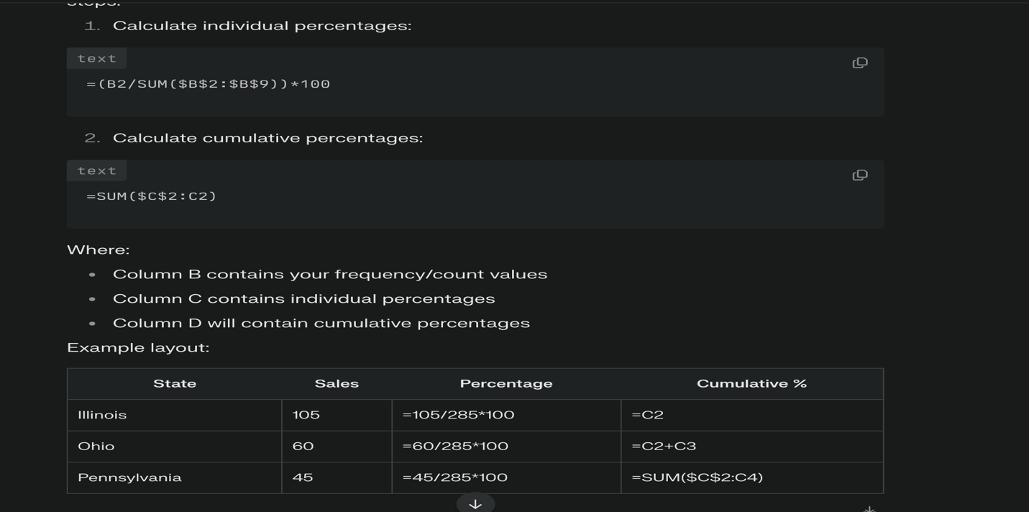

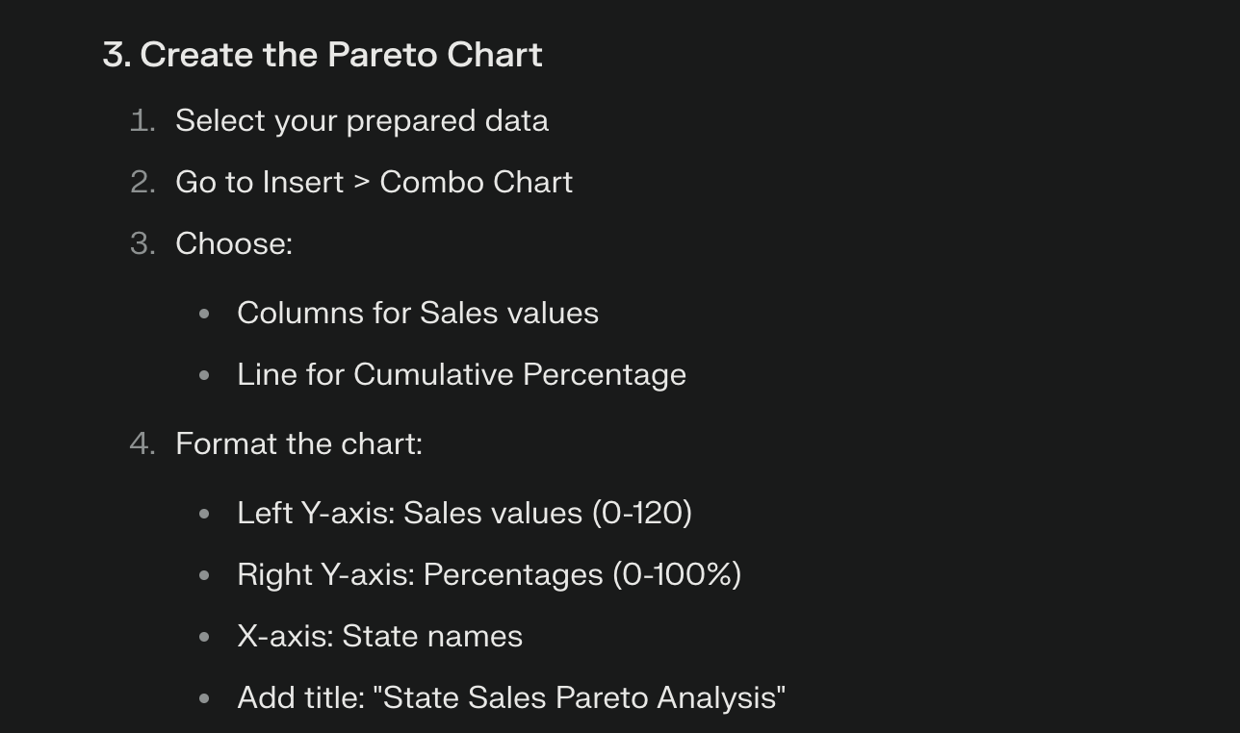

Excel:  
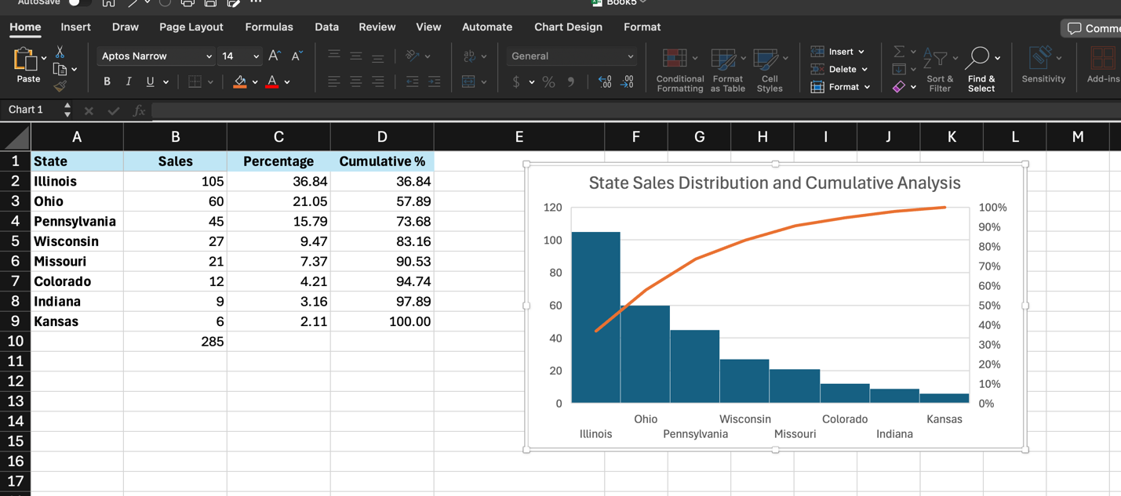

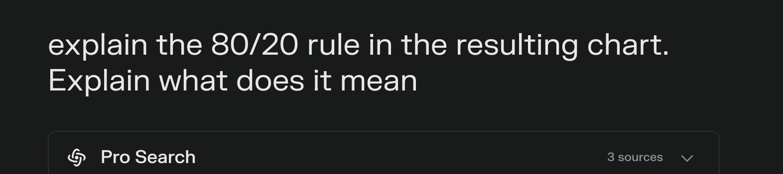

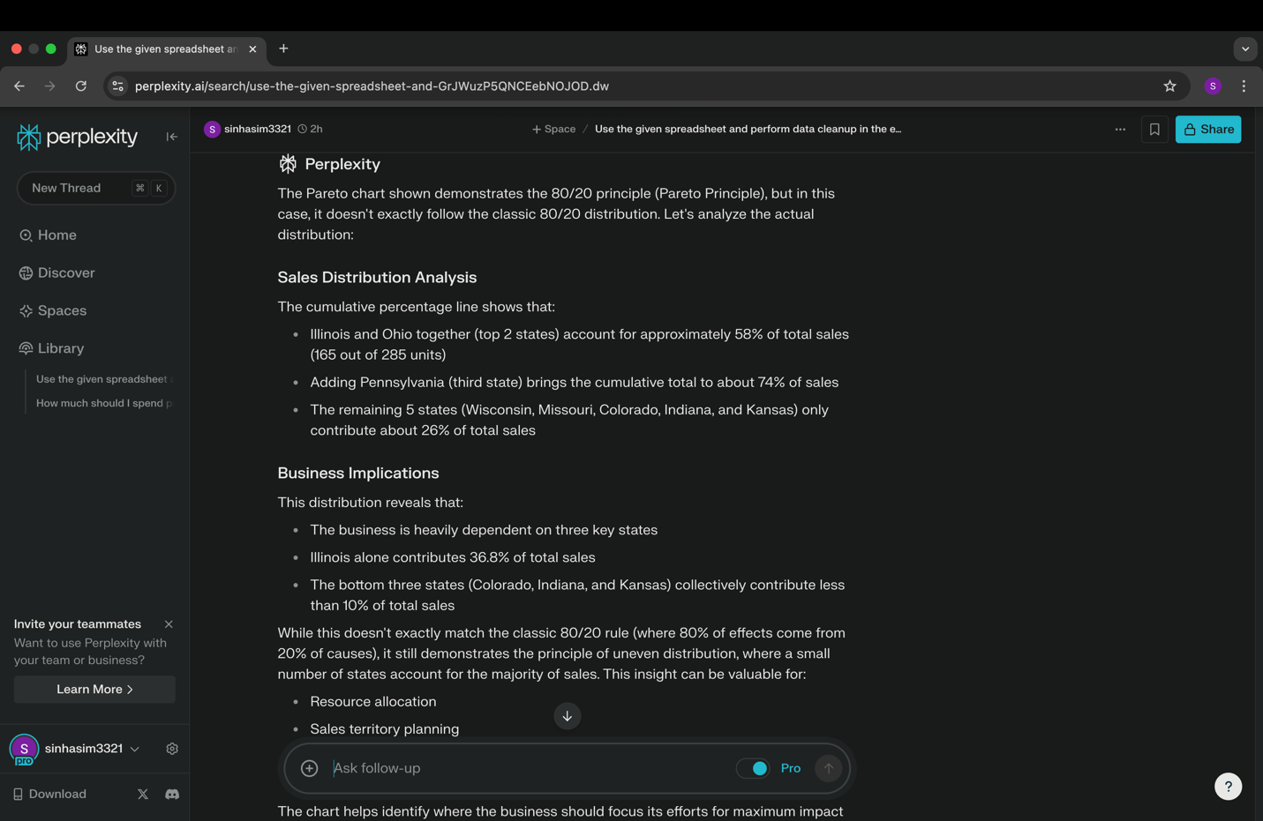

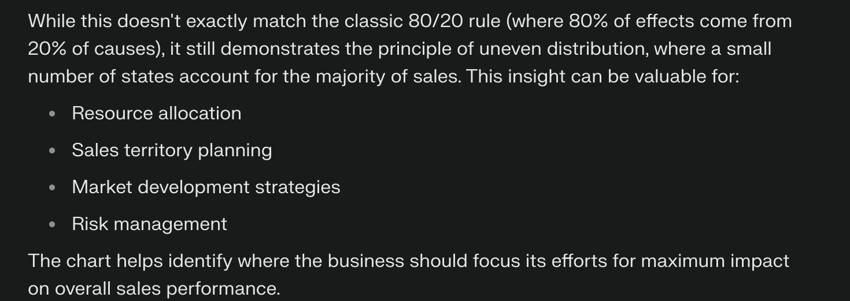

2. Use the StateSalesLong sheet in the “more charts.xlsx file to create the box &  
Whisker (Box) chart we did in class. Ask the bot to explain the insight of the  
resulting chart, including outliers. Ask the bot why use Box chart for better  
visualization  
Prompt: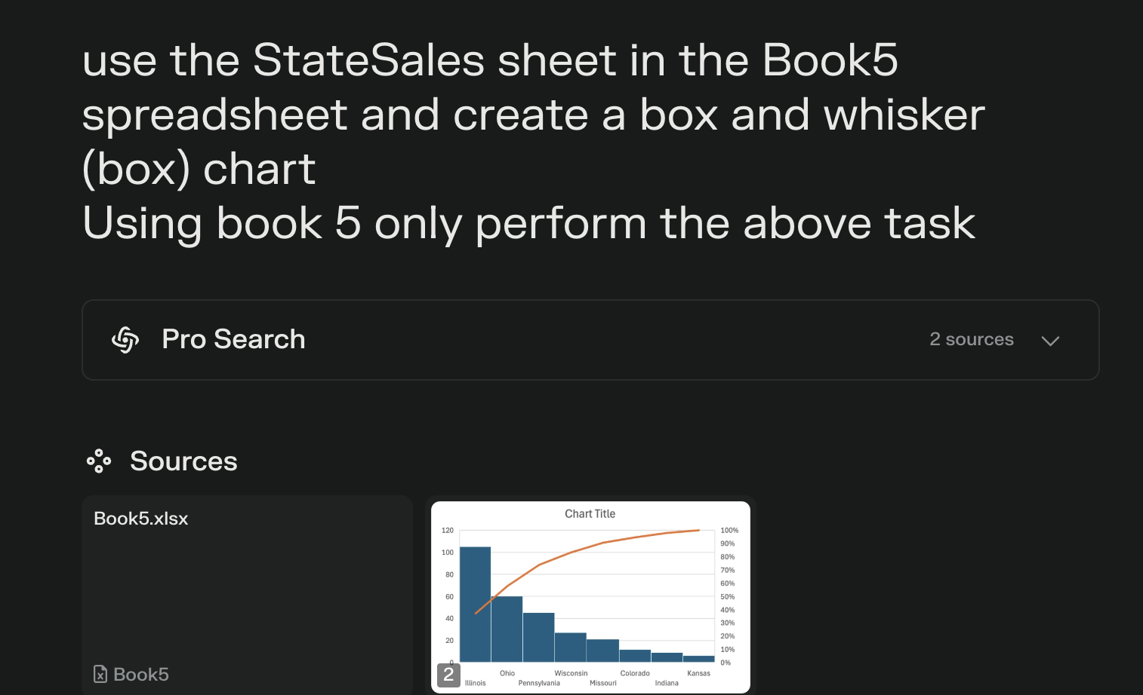  
Solution by AI:  
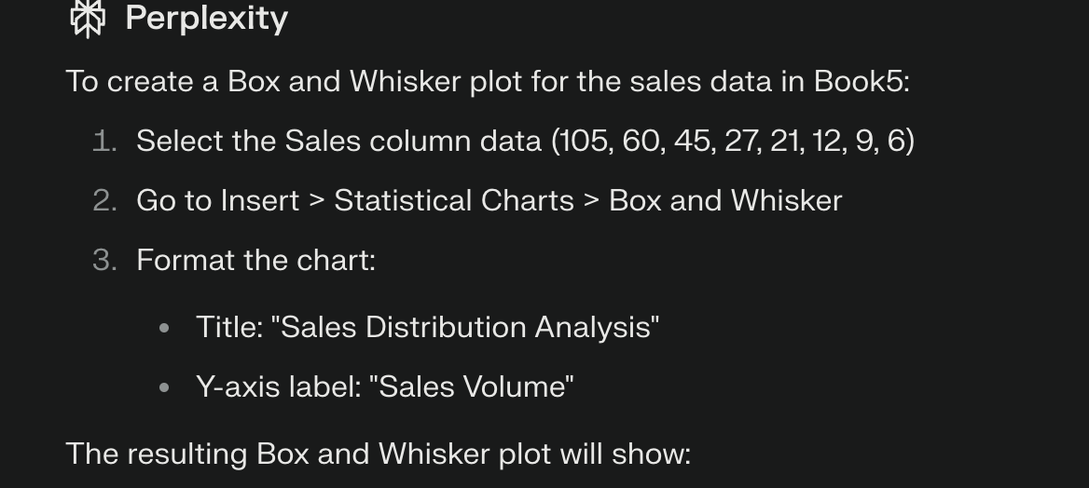  
Excel:  
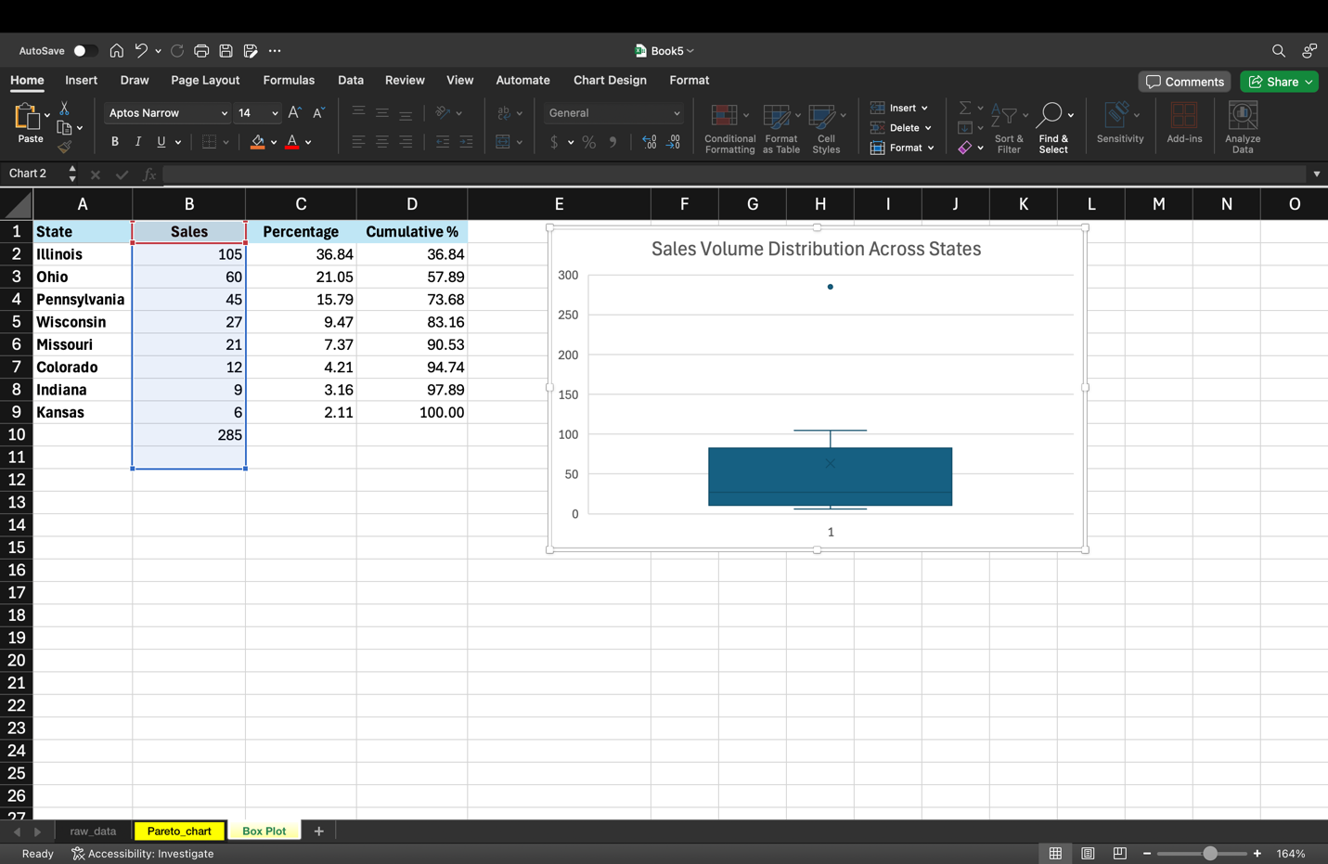  


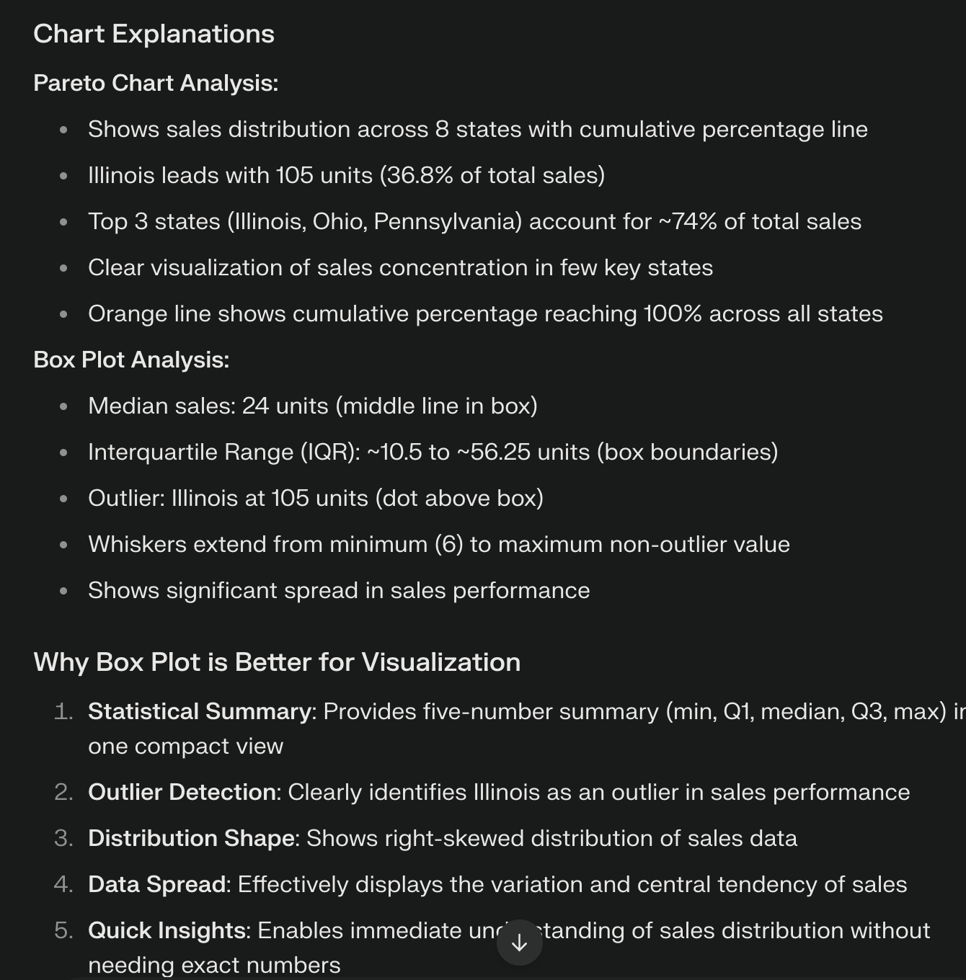

3. Use the Transactions sheet in Gen_AI_Prompt_Engineering.xlsx and ask Gen  
AI bot to categorize each transaction as debt or credit. Also ask the bot to  
create a bar chart to visualize the data

Prompt: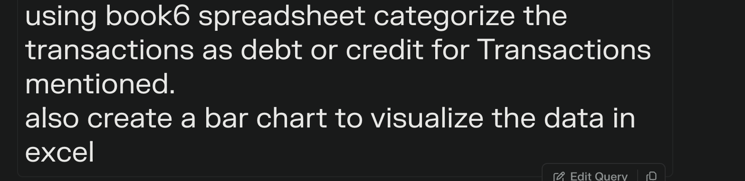  
Solution by AI:  
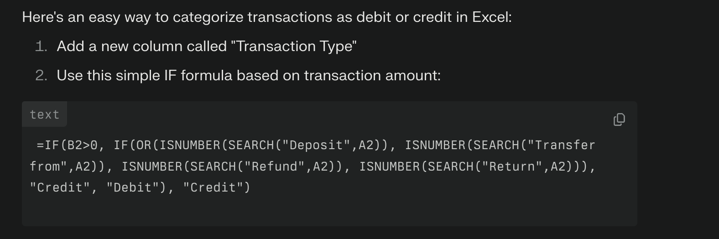  
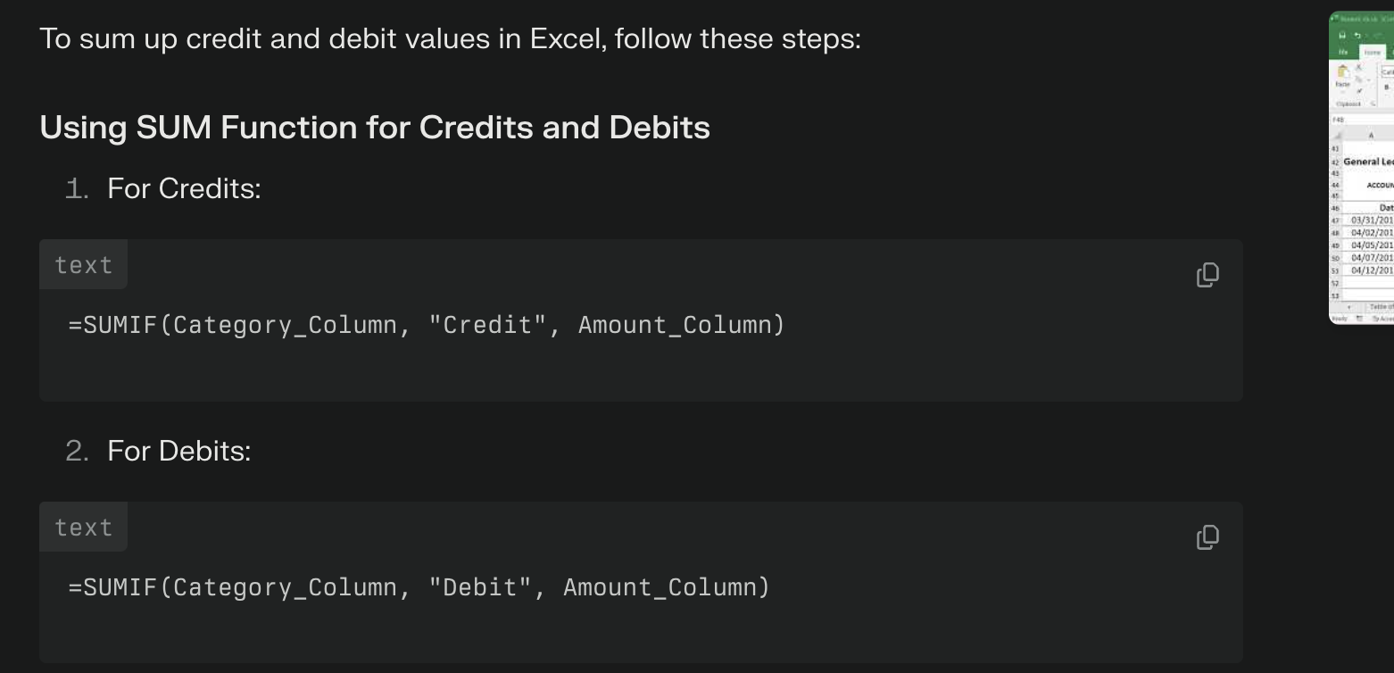  
Excel: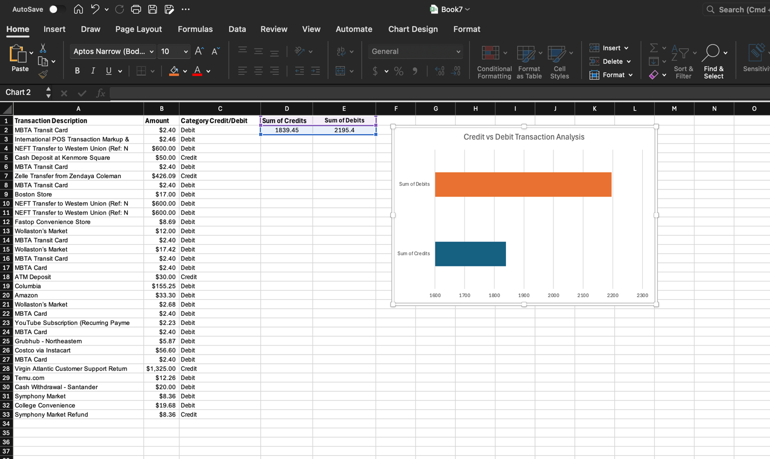  
4. Use the Restockings sheet in Gen_AI_Prompt_Engineering.xlsx and ask Gen  
AI bot to use its data to calculate the Recommended Restocking Quantity and  
display in in the Recommended Restocking Quantity column. Also ask the  
bot to create a bar chart to visualize the data. Also, copy the results to excel  
and submit file.   
Prompt: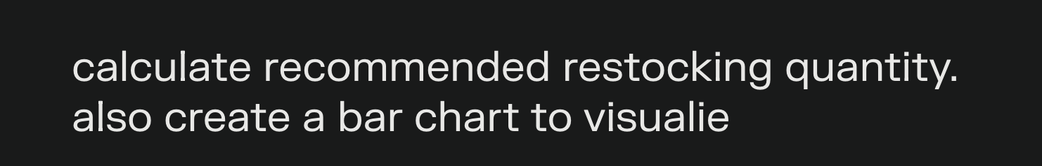  
Solution by AI: 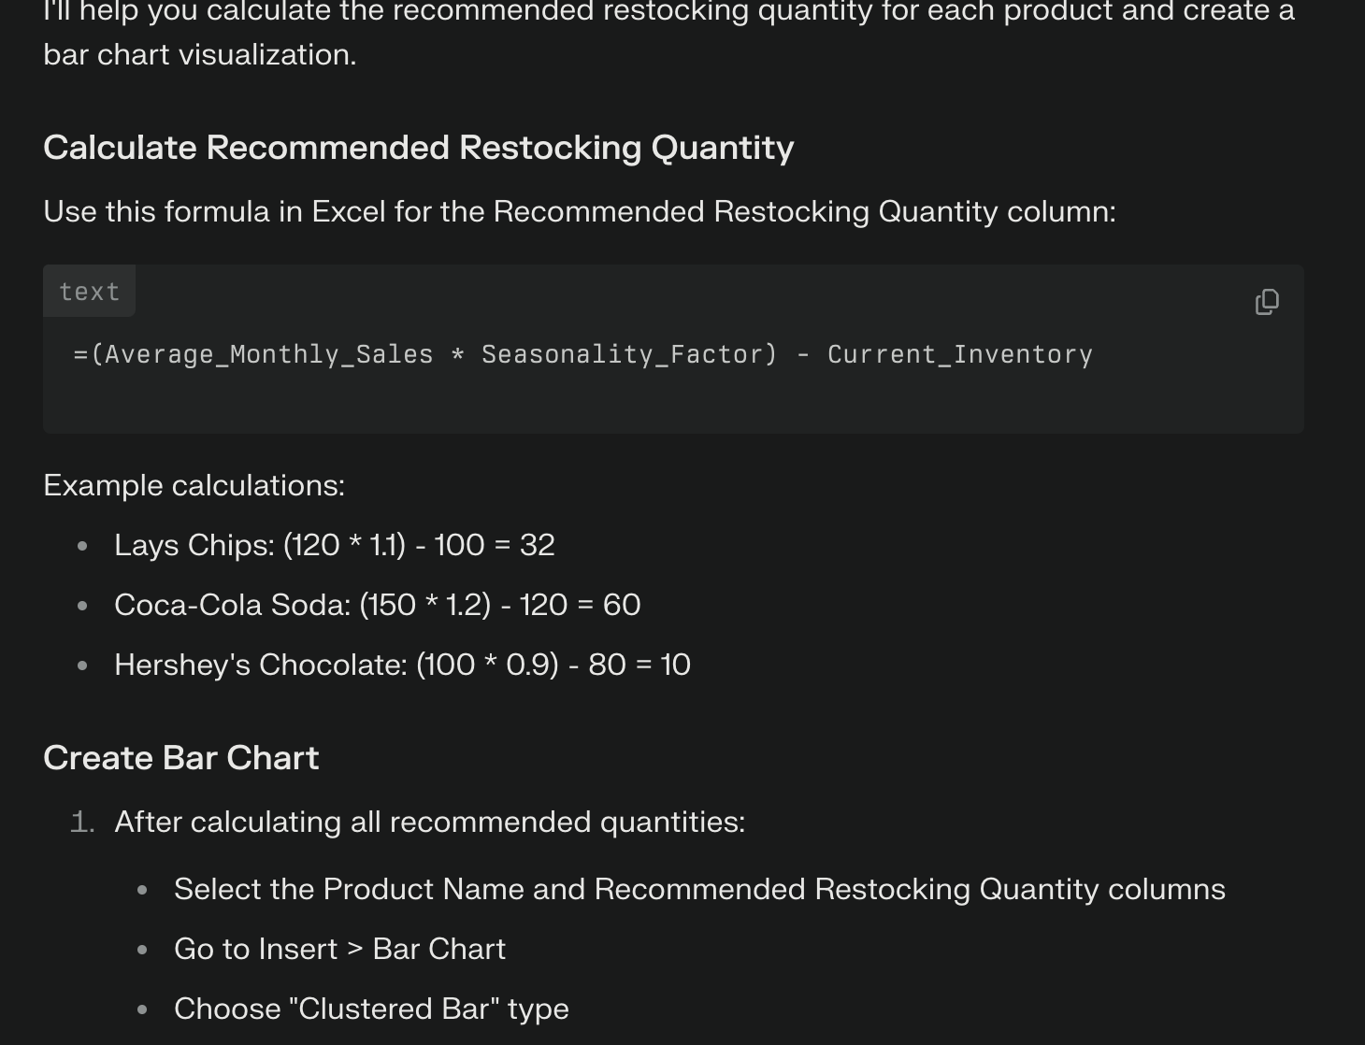  
Excel:

